**Face Recognition**

**Problem Statement:**

1. Explore the application of Convolutional Neural Networks (CNN) in matching extracted faces in images to a known identity in database using feature extraction, transfer learning, fine tuning, data augmentation, regularization, and CNN embeddings. We have 11 identities selected from the publicly available CASIA-WebFace dataset. First, 8 models are created repurposing pretrained models on the VGGFace2 dataset using VGG16 and Resnet50 architectures. VGGFace2 dataset contains 3.31 million images of 9131 subjects across different poses and ages. Then, a pretrained model that uses on MS-celeb-1M dataset with 1 million subjects and one image per person in the database is repurposed to classify an extracted face to one of the 11 subjects or ‘Not in database’. Performance of a total 9 models are compared and visualized.

**Overview of Technology:**

1. Do existing pretrained models correctly recognize faces in images?
2. How to improve performance of existing pretrained models using deep learning techniques?
3. What if we only have one image per person in our database? What if we want to add another person to the existing database for face recognition, or if the person in the image is not in our database?
4. What if there are multiple faces in the images?

**Data set:** Selected 11 classes of celebrities in CASIA-WebFace publicly available dataset([here](https://drive.google.com/file/d/1Of_EVz-yHV7QVWQGihYfvtny9Ne8qXVz/view)) This dataset is created by the Institute of Automation, Chinese Academy of Sciences (CASIA) gathered from IMDb profiles. CASIA WebFace Facial dataset includes 494,414 images over 10,575 identities.

**High Level Overview of steps:**

1. Create new environment, install softwares, download dataset from [here](https://drive.google.com/file/d/1Of_EVz-yHV7QVWQGihYfvtny9Ne8qXVz/view).
2. Clean images by extracting only one face from each image such that the area of the face is the largest.
3. Select 11 classes of dataset and split each class to three folders for training, validation, and testing.
4. Use pretrained models (VGG16 and Resnet50) to predict faces of the 11 subjects.
5. Train 8 models using feature extraction, transfer learning, and fine tuning with keras.
6. Use data augmentation and regularization to improve model performance and avoid overfitting.
7. Compare training and validation accuracy across 8 models and predicted class of faces for the 11 subjects.
8. Download FaceNet pretrained model and repurpose it to predict one of the 11 subjects or ‘Not in database’.
9. Create a function that classifies all faces in an image to one of the 11 subjects or ‘Not in database’.

**References:** Lecture notes: 5.5, 5.2, 5.3 and labs, Deep Learning with Python, Francois Chollet, Chapter 5.

**Hardware:** processor**:**  2.3 GHz Intel Core i9 , memory: 16 GB 2400 MHz DDR4

**Software:** Python 3.7.6 / Keras 2.1.0/ Keras-facenet/keras-vggface/tensorflow 2.1.0/Anaconda (jupyter notebook)

**Lessons Learned & Pros/Cons:**

1. Repurposing existing models, using a moderate size dataset, to match an extracted face to a known individual can significantly improve the prediction accuracy of pretrained models.
2. The performance of repurposed models strongly depends on the underlying network architecture and not necessarily the depth or number of layers. VGG16 yields higher validation accuracy with less layers retrained. VGG16 and Resnet50 models are both pretrained on the same VGGFace2 dataset. However, when more of the layers are retrained, model using ResNet50 improved more.
3. The performance of repurposed models strongly depends on the number of images in the underlying datasets and the learning algorithm of pretrained models. Repurposing FaceNet model with 1 million identities and one-shot learning algorithm strongly over performs repurposed models using VGG16 and ResNet50 with 9,131 identities that use many images per identity.
4. Fine tuning improved the validation accuracies more than transfer learning using models’ convolutional bases.
5. Models using VGG16’s convolutional base responded better than ReNet50 to the transfer learning when 1 or 2 layers added. Model using ReNet50’s convolutional base achieved the same accuracy by adding 2 hidden layers.
6. Model using Resnet50’s convolutional base responded better than VGG16 to finetuning.
7. There are many hyperparameters that could be optimized using hyperparameter-tuning technique. The selection of those parameters can impact the results and accuracies. Optimizing such parameters requires more time and computational power.
8. With the selected parameters, the validation and training accuracy and loss depicted enough selected epochs. Therefore, AWS was not used in this project.

**YouTube URLs:** <https://www.youtube.com/watch?v=JfPWQ8RJ6LM>

**Long video:** <https://www.youtube.com/watch?v=wrOLiOygwJU>

# Report of Final Project of Deep Leaning

# Face Recognition

# Tina Rezvanian

# Codes from notebook FaceRecogition_TinaRezvanian_CodePart1.ipynb:

# Do existing pretrained models correctly recognize faces in images?

We will use 2 pretrained models with vgg16 and resNet50 architectures that are trained on the VGGface2 data set. VGGFace2 dataset is developed by researchers at the Visual Geometry Group at Oxford, includes faces across different poses and ages. The dataset contains 3.31 million images of 9131 subjects (including actors, athletes, politicians), approximately 362 images for each subject. This two pretrained models (VGG16 and ResNet50 trained on VGGFACE2 dataset) are available in package 'keras_vggface' available (https://github.com/rcmalli/keras-vggface). This data set has 8631 to 500 train and validation split on the identities. When specifying weights for loading pretrained VGGFace models, one of ‘None’ (random initialization) or "vggface" (pre-training on VGGFACE datasets). This work only uses weight pretrained on 'vggface'.

This project uses the following dataset for prediction:

Selected 11 classes of celebrities in CASIA-WebFace publicly available dataset(here) This dataset is created by the Institute of Automation, Chinese Academy of Sciences (CASIA) gathered from IMDb profiles. Labels and image list of CASIA WebFace data set can be found here. CASIA WebFace Facial dataset includes 494,414 images over 10,575 identities and requires some filtering for quality. The number of images in each class averages 46 image per subject, however, for this project 11 classes with at least 180 images are selected. Some of the candidate images for prediction are located in 'test_dir'. We use images in this directory to illustrate some of the predictions on images not seen by any models.

Input for these two models require a face detector. For that reason, I use the detector MTCNN in package mtcnn.mtcnn. The 'preprocess_input' function of the 'keras_vggface.utils' package is used to prepare the face to become the input of the models.(required size is 224 × 224 crop of the center face image is used as input to the network). The face descriptor or the embeddings is extracted from the layer adjacent to the classifier layer. This leads to a 2048-dimensional descriptor, which is then L2 normalized.

Before going through the project we set up a new environment and install softwares in requirement.txt file. Instructions are for Mac OS.

**Set up environment:**

conda create -n DLpy37 python=3.7.6 anaconda

conda activate DLpy37

pip install tensorflow

pip install keras

sudo pip install git+https://github.com/rcmalli/keras-vggface.git

pip install -r requirements.txt

! pip show keras-vggface

Name: keras-vggface Version: 0.6

Summary: VGGFace implementation with Keras framework Home-page: https://github.com/rcmalli/keras-vggface Author: Refik Can MALLI

Author-email: [mallir@itu.edu.tr](mailto:mallir@itu.edu.tr) License: MIT

Location: /anaconda3/envs/DLpy37/lib/python3.7/site-packages Requires: pyyaml, pillow, six, keras, numpy, h5py, scipy Required-by:

**import keras_vggface**

[3]:

! python --version

Python 3.7.6

[5]:

[10]:

IMG_SIZE = 224

IMG_SHAPE = (IMG_SIZE, IMG_SIZE, 3)

required_size = (IMG_SIZE, IMG_SIZE)

*# Tesing set*

test_dir = 'keras-facenet/data/test'

## import os

*# os.environ['KMP_DUPLICATE_LIB_OK']='True'from future import*␣

*'→absolute_import, division, print_function, unicode_literals*

## import pathlib import os

**import matplotlib.pyplot as plt from matplotlib import** pyplot **import numpy as np**

**from numpy import** expand_dims **from numpy import** asarray **import pandas as pd**

## import seaborn as sns

**from IPython import** display

**from PIL import** Image

**from IPython import** display

## import cv2

**import keras_vggface import keras**

**from keras import** layers

**from keras import** models

**from keras import** regularizers

**from keras import** optimizers

## from keras.preprocessing import image

**from keras.preprocessing.image import** ImageDataGenerator, array_to_img,␣

*'→*img_to_array, load_img

**from keras.models import** load_model

## from keras.layers import *

**from keras.models import** Sequential

## from keras_vggface.vggface import VGGFace

**from keras_vggface.utils import** preprocess_input **from keras_vggface.utils import** decode_predictions **from keras import** regularizers

**from keras.utils import** to_categorical

## from mtcnn.mtcnn import MTCNN

listGroupsTest = os.listdir(test_dir)

listGroupsTest = [f **for** f **in** listGroupsTest **if not** f.startswith('.')] listGroupsTest

[10]: ['Teri_Hatcher',

'Geena_Davis', 'Neve_Campbell', 'Kevin_Bacon', 'Patricia_Arquette', 'Steve_Buscemi', 'Kim_Basinger', 'David_Duchovny', 'Helen_Hunt', 'Colin_Firth', 'Jeff_Goldblum']

[99]:

**def** extract_face(img_path, required_size=required_size):

*# load image from file*

img = cv2.imread(img_path)

img_rgb = cv2.cvtColor(img, cv2.COLOR_BGR2RGB)

*# create detector, using default weights*

detector = MTCNN()

*# detect faces in the image*

results = detector.detect_faces(img_rgb)

*# extract the bounding box associated to larger area*

bigger_face = max(results, key=**lambda** b: b['box'][2] * b['box'][3]) x1, y1, width, height = bigger_face['box']

x2, y2 = x1 + width, y1 + height

*# extract the face*

face = img_rgb[y1:y2, x1:x2] image = Image.fromarray(face)

image = image.resize(required_size) face_array = asarray(image)

**return** face_array

[71]:

*# example of face extraction:*

img_path = 'Data/train/Colin_Firth/001.jpg' img = cv2.imread(img_path)

img_rgb = cv2.cvtColor(img, cv2.COLOR_BGR2RGB) plt.imshow(img_rgb)

plt.show()

face = extract_face(img_path) plt.imshow(face)

plt.show()

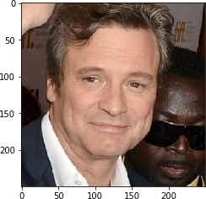

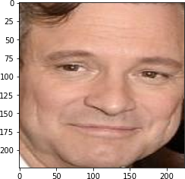

# Predict using pretrained models:

[11]:

**def** prepare_image_pretrained(img_path, img_size = IMG_SIZE): face = extract_face(img_path)

face = face.astype('float32') face = expand_dims(face, axis=0)

samples = keras_vggface.utils.preprocess_input(face, version=2)

**return** samples

**def** faceClassifier_pretrained(model, imagePath): preprocessed_image = prepare_image_pretrained(imagePath) *# Use pretrained model to classify the image*

predictions = model.predict(preprocessed_image) results = decode_predictions(predictions) **return** results

[12]:

**def** faceRecognition_pretrained(model, test_dir): predictions_list=[]

**for** celeb **in** os.listdir(test_dir):

**if not** celeb.startswith('.'):

test_img_path = os.path.join(test_dir, celeb)

**if not** test_img_path.startswith('.'):

**for** test_img **in** os.listdir(test_img_path):

**if not** test_img.startswith('.'):

fullimagepath = os.path.join(test_img_path, test_img) face = prepare_image_pretrained(fullimagepath) predictions = model.predict(face) predictions_list.append(predictions)

predictions = np.sum(predictions_list, axis=0) top_pred = decode_predictions(predictions)

print('Test picture from: ', celeb,':**\n** Prediction: ' ,top_pred, '**\n**')

# VGG16:

[13]:

*# Lets predict using exisiting pretrained vgg16 model* vgg16 = VGGFace(model='vgg16') faceRecognition_pretrained(vgg16, test_dir)

Test picture from: Teri_Hatcher :

Prediction: [[["b'Teri_Hatcher'", 0.53289264], ["b'Marina_Sirtis'", 0.034269728], ["b'Marisol_Nichols'", 0.020355703], ["b'Bahar_Soomekh'",

0.016289664], ["b'Tamara_Feldman'", 0.014841828]]]

Test picture from: Geena_Davis :

Prediction: [[["b'Geena_Davis'", 0.97315073], ["b'Teri_Hatcher'", 0.53289354],

["b'Marina_Sirtis'", 0.034270935], ["b'Marisol_Nichols'", 0.020357871],

["b'Bahar_Soomekh'", 0.016321553]]]

Test picture from: Neve_Campbell :

Prediction: [[["b'Neve_Campbell'", 0.998247], ["b'Geena_Davis'", 0.97315073],

["b'Teri_Hatcher'", 0.53289366], ["b'Marina_Sirtis'", 0.03427095],

["b'Marisol_Nichols'", 0.02035795]]]

Test picture from: Kevin_Bacon :

Prediction: [[["b'Neve_Campbell'", 0.9982632], ["b'Geena_Davis'", 0.9731526],

["b'Kevin_Bacon'", 0.62608254], ["b'Teri_Hatcher'", 0.5328978],

["b'Marina_Sirtis'", 0.034274735]]]

Test picture from: Patricia_Arquette :

Prediction: [[["b'Neve_Campbell'", 0.998648], ["b'Geena_Davis'", 0.97316146],

["b'Kevin_Bacon'", 0.6260855], ["b'Teri_Hatcher'", 0.5328991],

["b'Olga_Kurylenko'", 0.1379144]]]

Test picture from: Steve_Buscemi :

Prediction: [[["b'Neve_Campbell'", 0.9986786], ["b'Geena_Davis'", 0.97320145],

["b'Kevin_Bacon'", 0.62609726], ["b'Teri_Hatcher'", 0.53297365],

["b'Olga_Kurylenko'", 0.13807096]]]

Test picture from: Kim_Basinger :

Prediction: [[["b'Neve_Campbell'", 0.99881387], ["b'Geena_Davis'", 0.97394097], ["b'Kevin_Bacon'", 0.62615347], ["b'Teri_Hatcher'", 0.53309536],

["b'Olga_Kurylenko'", 0.1380752]]]

Test picture from: David_Duchovny :

Prediction: [[["b'Neve_Campbell'", 0.99882376], ["b'Geena_Davis'", 0.9739497],

["b'Kevin_Bacon'", 0.62617624], ["b'Teri_Hatcher'", 0.53311515],

["b'Olga_Kurylenko'", 0.13810477]]]

Test picture from: Helen_Hunt :

Prediction: [[["b'Neve_Campbell'", 0.99882376], ["b'Helen_Hunt'", 0.99269545],

["b'Geena_Davis'", 0.9739497], ["b'Kevin_Bacon'", 0.62617624],

["b'Teri_Hatcher'", 0.53311515]]]

Test picture from: Colin_Firth :

Prediction: [[["b'Neve_Campbell'", 0.9988239], ["b'Helen_Hunt'", 0.9927002],

["b'Geena_Davis'", 0.9739514], ["b'Colin_Firth'", 0.8744785], ["b'Kevin_Bacon'",

0.62617725]]]

Test picture from: Jeff_Goldblum :

Prediction: [[["b'Neve_Campbell'", 0.99882394], ["b'Helen_Hunt'", 0.9927017],

["b'Geena_Davis'", 0.9739515], ["b'Jeff_Goldblum'", 0.97236156],

["b'Colin_Firth'", 0.8744903]]]

[16]:

vgg16.summary()

Model: "vggface_vgg16"

Layer (type) Output Shape Param #

=================================================================

input_4 (InputLayer) (None, 224, 224, 3) 0

|  |  |  |  |  |
| --- | --- | --- | --- | --- |
| conv1_1 (Conv2D) | (None, | 224, | 224, 64) | 1792 |
| conv1_2 (Conv2D) | (None, | 224, | 224, 64) | 36928 |
| pool1 (MaxPooling2D) | (None, | 112, | 112, 64) | 0 |
| conv2_1 (Conv2D) | (None, | 112, | 112, 128) | 73856 |
| conv2_2 (Conv2D) | (None, | 112, | 112, 128) | 147584 |
| pool2 (MaxPooling2D) | (None, | 56, | 56, 128) | 0 |
| conv3_1 (Conv2D) | (None, | 56, | 56, 256) | 295168 |
| conv3_2 (Conv2D) | (None, | 56, | 56, 256) | 590080 |
| conv3_3 (Conv2D) | (None, | 56, | 56, 256) | 590080 |
| pool3 (MaxPooling2D) | (None, | 28, | 28, 256) | 0 |
| conv4_1 (Conv2D) | (None, | 28, | 28, 512) | 1180160 |
| conv4_2 (Conv2D) | (None, | 28, | 28, 512) | 2359808 |
| conv4_3 (Conv2D) | (None, | 28, | 28, 512) | 2359808 |
| pool4 (MaxPooling2D) | (None, | 14, | 14, 512) | 0 |
| conv5_1 (Conv2D) | (None, | 14, | 14, 512) | 2359808 |
| conv5_2 (Conv2D) | (None, | 14, | 14, 512) | 2359808 |
| conv5_3 (Conv2D) | (None, | 14, | 14, 512) | 2359808 |
| pool5 (MaxPooling2D) | (None, | 7, 7, 512) | | 0 |
| flatten (Flatten) | (None, | 25088) | | 0 |
| fc6 (Dense) | (None, | 4096) | | 102764544 |

|  |  |  |  |
| --- | --- | --- | --- |
| fc6/relu (Activation) | (None, | 4096) | 0 |
| fc7 (Dense) | (None, | 4096) | 16781312 |
| fc7/relu (Activation) | (None, | 4096) | 0 |
| fc8 (Dense) | (None, | 2622) | 10742334 |
| fc8/softmax (Activation) | (None, | 2622) | 0 |

=================================================================

Total params: 145,002,878

Trainable params: 145,002,878

Non-trainable params: 0

# ResNet50:

[14]:

*# Lets predict using exisiting pretrained resnet50 model* resnet50 = VGGFace(model='resnet50') faceRecognition_pretrained(resnet50, test_dir)

Test picture from: Teri_Hatcher :

Prediction: [[["b' Ay\\xc5\\x9feg\\xc3\\xbcl_Aldin\\xc3\\xa7'", 0.17874312], ["b' Peggy_Lipton'", 0.08712374], ["b' Valeria_Solarino'", 0.028685542], ["b' Micaela_Ramazzotti'", 0.027750503], ["b' Lana_Parrilla'", 0.02382494]]]

Test picture from: Geena_Davis :

Prediction: [[["b' Ay\\xc5\\x9feg\\xc3\\xbcl_Aldin\\xc3\\xa7'", 0.17875075], ["b' Melissa_Sagemiller'", 0.102681205], ["b' Peggy_Lipton'", 0.08717244], ["b' Stefanie_Stappenbeck'", 0.03472344], ["b' Dedee_Pfeiffer'", 0.032279067]]]

Test picture from: Neve_Campbell :

Prediction: [[["b' Raquel_S\\xc3\\xa1nchez-Silva'", 0.20582676], ["b' Ay\\xc5\\x9feg\\xc3\\xbcl_Aldin\\xc3\\xa7'", 0.17900482], ["b' Ana_Claudia_Talanc\\xc3\\xb3n'", 0.14541118], ["b' Natasza_Urba\\xc5\\x84ska'", 0.10859329], ["b' Melissa_Sagemiller'", 0.10268208]]]

Test picture from: Kevin_Bacon :

Prediction: [[["b' Raquel_S\\xc3\\xa1nchez-Silva'", 0.20582817], ["b' Ay\\xc5\\x9feg\\xc3\\xbcl_Aldin\\xc3\\xa7'", 0.17900893], ["b'

Ana_Claudia_Talanc\\xc3\\xb3n'", 0.14541325], ["b' David_Caruso'", 0.118176855],

["b' Natasza_Urba\\xc5\\x84ska'", 0.10859391]]]

Test picture from: Patricia_Arquette :

Prediction: [[["b' Raquel_S\\xc3\\xa1nchez-Silva'", 0.20583415], ["b'

Ay\\xc5\\x9feg\\xc3\\xbcl_Aldin\\xc3\\xa7'", 0.17958523], ["b'

Ana_Claudia_Talanc\\xc3\\xb3n'", 0.14685358], ["b' Robin_Wright'", 0.14611211],

["b' David_Caruso'", 0.11818524]]]

Test picture from: Steve_Buscemi :

Prediction: [[["b' Raquel_S\\xc3\\xa1nchez-Silva'", 0.20584065], ["b' Ay\\xc5\\x9feg\\xc3\\xbcl_Aldin\\xc3\\xa7'", 0.17975567], ["b' Max_Pezzali'", 0.17402261], ["b' Ana_Claudia_Talanc\\xc3\\xb3n'", 0.14685449], ["b'

Robin_Wright'", 0.14611967]]]

Test picture from: Kim_Basinger :

Prediction: [[["b' Raquel_S\\xc3\\xa1nchez-Silva'", 0.20584588], ["b' Ay\\xc5\\x9feg\\xc3\\xbcl_Aldin\\xc3\\xa7'", 0.17989142], ["b' Max_Pezzali'", 0.17403221], ["b' Ana_Claudia_Talanc\\xc3\\xb3n'", 0.14687073], ["b'

Robin_Wright'", 0.14624599]]]

Test picture from: David_Duchovny :

Prediction: [[["b' Raquel_S\\xc3\\xa1nchez-Silva'", 0.20585334], ["b' Ay\\xc5\\x9feg\\xc3\\xbcl_Aldin\\xc3\\xa7'", 0.17991792], ["b' Max_Pezzali'", 0.17404984], ["b' Ana_Claudia_Talanc\\xc3\\xb3n'", 0.14687909], ["b'

Robin_Wright'", 0.14625056]]]

Test picture from: Helen_Hunt :

Prediction: [[["b' Raquel_S\\xc3\\xa1nchez-Silva'", 0.20590375], ["b' Ay\\xc5\\x9feg\\xc3\\xbcl_Aldin\\xc3\\xa7'", 0.17995432], ["b' Max_Pezzali'", 0.17405117], ["b' Robin_Wright'", 0.16926996], ["b'

Ana_Claudia_Talanc\\xc3\\xb3n'", 0.14692284]]]

Test picture from: Colin_Firth :

Prediction: [[["b' Raquel_S\\xc3\\xa1nchez-Silva'", 0.2060756], ["b' Ay\\xc5\\x9feg\\xc3\\xbcl_Aldin\\xc3\\xa7'", 0.17996891], ["b' Max_Pezzali'", 0.17414661], ["b' Robin_Wright'", 0.16948111], ["b'

Ana_Claudia_Talanc\\xc3\\xb3n'", 0.14692947]]]

Test picture from: Jeff_Goldblum :

Prediction: [[["b' Raquel_S\\xc3\\xa1nchez-Silva'", 0.20612243], ["b' Ay\\xc5\\x9feg\\xc3\\xbcl_Aldin\\xc3\\xa7'", 0.18008852], ["b' Max_Pezzali'", 0.17415121], ["b' Robin_Wright'", 0.16948879], ["b'

Ana_Claudia_Talanc\\xc3\\xb3n'", 0.14693046]]]

Let us take a look at the VGG16 and ResNet50 networks:

[15]:

resnet50.summary()

Model: "vggface_resnet50"

Layer (type) Output Shape Param # Connected to

|  |  |  |  |  |  |  |
| --- | --- | --- | --- | --- | --- | --- |
| input_38 (InputLayer) | (None, | 224, | 224, | | 3) | 0 |
|  |  |  |  | |  |  |
| conv1/7x7_s2 (Conv2D) | (None, | 112, | 112, | | 64) | 9408 input_38[0][0] |
|  |  |  |  | |  |  |
| conv1/7x7_s2/bn (BatchNormaliza conv1/7x7_s2[0][0] | (None, | 112, | 112, | | 64) | 256 |
|  |  |  |  | |  |  |
| activation_1 (Activation) conv1/7x7_s2/bn[0][0] | (None, | 112, | 112, | | 64) | 0 |
| max_pooling2d_73 (MaxPooling2D) activation_1[0][0] | (None, | 55, | 55, | 64) | | 0 |
|  |  |  |  |  | |  |
| conv2_1_1x1_reduce (Conv2D) max_pooling2d_73[0][0] | (None, | 55, | 55, | 64) | | 4096 |
|  |  |  |  |  | |  |
| conv2_1_1x1_reduce/bn (BatchNor conv2_1_1x1_reduce[0][0] | (None, | 55, | 55, | 64) | | 256 |
|  |  |  |  |  | |  |
| activation_2 (Activation) conv2_1_1x1_reduce/bn[0][0] | (None, | 55, | 55, | 64) | | 0 |
|  |  |  |  |  | |  |
| conv2_1_3x3 (Conv2D) activation_2[0][0] | (None, | 55, | 55, | 64) | | 36864 |
|  |  |  |  |  | |  |
| conv2_1_3x3/bn (BatchNormalizat conv2_1_3x3[0][0] | (None, | 55, | 55, | 64) | | 256 |
|  |  |  |  |  | |  |
| activation_3 (Activation) conv2_1_3x3/bn[0][0] | (None, | 55, | 55, | 64) | | 0 |
|  |  |  |  |  | |  |
| conv2_1_1x1_increase (Conv2D) activation_3[0][0] | (None, | 55, | 55, | 256) | | 16384 |
|  |  |  |  |  | |  |
| conv2_1_1x1_proj (Conv2D) | (None, | 55, | 55, | 256) | | 16384 |

|  |  |  |  |  |  |
| --- | --- | --- | --- | --- | --- |
| max_pooling2d_73[0][0] |  | | | | |
|  |  |  |  |  |  |
| conv2_1_1x1_increase/bn (BatchN conv2_1_1x1_increase[0][0] | (None, | 55, | 55, | 256) | 1024 |
|  |  |  |  |  |  |
| conv2_1_1x1_proj/bn (BatchNorma conv2_1_1x1_proj[0][0] | (None, | 55, | 55, | 256) | 1024 |
|  |  |  |  |  |  |
| add_1 (Add) conv2_1_1x1_increase/bn[0][0] conv2_1_1x1_proj/bn[0][0] | (None, | 55, | 55, | 256) | 0 |
|  |  |  |  |  |  |
| activation_4 (Activation) | (None, | 55, | 55, | 256) | 0 add_1[0][0] |
|  |  |  |  |  |  |
| conv2_2_1x1_reduce (Conv2D) activation_4[0][0] | (None, | 55, | 55, | 64) | 16384 |
|  |  |  |  |  |  |
| conv2_2_1x1_reduce/bn (BatchNor conv2_2_1x1_reduce[0][0] | (None, | 55, | 55, | 64) | 256 |
|  |  |  |  |  |  |
| activation_5 (Activation) conv2_2_1x1_reduce/bn[0][0] | (None, | 55, | 55, | 64) | 0 |
|  |  |  |  |  |  |
| conv2_2_3x3 (Conv2D) activation_5[0][0] | (None, | 55, | 55, | 64) | 36864 |
|  |  |  |  |  |  |
| conv2_2_3x3/bn (BatchNormalizat conv2_2_3x3[0][0] | (None, | 55, | 55, | 64) | 256 |
|  |  |  |  |  |  |
| activation_6 (Activation) conv2_2_3x3/bn[0][0] | (None, | 55, | 55, | 64) | 0 |
|  |  |  |  |  |  |
| conv2_2_1x1_increase (Conv2D) activation_6[0][0] | (None, | 55, | 55, | 256) | 16384 |
|  |  |  |  |  |  |
| conv2_2_1x1_increase/bn (BatchN | (None, | 55, | 55, | 256) | 1024 |

|  |  |  |  |  |  |
| --- | --- | --- | --- | --- | --- |
| conv2_2_1x1_increase[0][0] |  |  |  |  |  |
|  |  |  |  |  |  |
| add_2 (Add) conv2_2_1x1_increase/bn[0][0] activation_4[0][0] | (None, | 55, | 55, | 256) | 0 |
|  |  |  |  |  |  |
| activation_7 (Activation) | (None, | 55, | 55, | 256) | 0 add_2[0][0] |
|  |  |  |  |  |  |
| conv2_3_1x1_reduce (Conv2D) activation_7[0][0] | (None, | 55, | 55, | 64) | 16384 |
|  |  |  |  |  |  |
| conv2_3_1x1_reduce/bn (BatchNor conv2_3_1x1_reduce[0][0] | (None, | 55, | 55, | 64) | 256 |
|  |  |  |  |  |  |
| activation_8 (Activation) conv2_3_1x1_reduce/bn[0][0] | (None, | 55, | 55, | 64) | 0 |
|  |  |  |  |  |  |
| conv2_3_3x3 (Conv2D) activation_8[0][0] | (None, | 55, | 55, | 64) | 36864 |
|  |  |  |  |  |  |
| conv2_3_3x3/bn (BatchNormalizat conv2_3_3x3[0][0] | (None, | 55, | 55, | 64) | 256 |
|  |  |  |  |  |  |
| activation_9 (Activation) conv2_3_3x3/bn[0][0] | (None, | 55, | 55, | 64) | 0 |
|  |  |  |  |  |  |
| conv2_3_1x1_increase (Conv2D) activation_9[0][0] | (None, | 55, | 55, | 256) | 16384 |
|  |  |  |  |  |  |
| conv2_3_1x1_increase/bn (BatchN conv2_3_1x1_increase[0][0] | (None, | 55, | 55, | 256) | 1024 |
|  |  |  |  |  |  |
| add_3 (Add) conv2_3_1x1_increase/bn[0][0] activation_7[0][0] | (None, | 55, | 55, | 256) | 0 |

|  |  |  |  |  |  |
| --- | --- | --- | --- | --- | --- |
| activation_10 (Activation) | (None, | 55, | 55, | 256) | 0 add_3[0][0] |
|  |  |  |  |  |  |
| conv3_1_1x1_reduce (Conv2D) activation_10[0][0] | (None, | 28, | 28, | 128) | 32768 |
|  |  |  |  |  |  |
| conv3_1_1x1_reduce/bn (BatchNor conv3_1_1x1_reduce[0][0] | (None, | 28, | 28, | 128) | 512 |
|  |  |  |  |  |  |
| activation_11 (Activation) conv3_1_1x1_reduce/bn[0][0] | (None, | 28, | 28, | 128) | 0 |
|  |  |  |  |  |  |
| conv3_1_3x3 (Conv2D) activation_11[0][0] | (None, | 28, | 28, | 128) | 147456 |
|  |  |  |  |  |  |
| conv3_1_3x3/bn (BatchNormalizat conv3_1_3x3[0][0] | (None, | 28, | 28, | 128) | 512 |
|  |  |  |  |  |  |
| activation_12 (Activation) conv3_1_3x3/bn[0][0] | (None, | 28, | 28, | 128) | 0 |
|  |  |  |  |  |  |
| conv3_1_1x1_increase (Conv2D) activation_12[0][0] | (None, | 28, | 28, | 512) | 65536 |
|  |  |  |  |  |  |
| conv3_1_1x1_proj (Conv2D) activation_10[0][0] | (None, | 28, | 28, | 512) | 131072 |
|  |  |  |  |  |  |
| conv3_1_1x1_increase/bn (BatchN conv3_1_1x1_increase[0][0] | (None, | 28, | 28, | 512) | 2048 |
|  |  |  |  |  |  |
| conv3_1_1x1_proj/bn (BatchNorma conv3_1_1x1_proj[0][0] | (None, | 28, | 28, | 512) | 2048 |
|  |  |  |  |  |  |
| add_4 (Add) conv3_1_1x1_increase/bn[0][0] conv3_1_1x1_proj/bn[0][0] | (None, | 28, | 28, | 512) | 0 |

|  |  |  |  |  |  |  |
| --- | --- | --- | --- | --- | --- | --- |
| activation_13 (Activation) | (None, | 28, | 28, | 512) | 0 | add_4[0][0] |
|  |  |  |  |  |  |  |
| conv3_2_1x1_reduce (Conv2D) activation_13[0][0] | (None, | 28, | 28, | 128) | 65536 |  |
|  |  |  |  |  |  |  |
| conv3_2_1x1_reduce/bn (BatchNor conv3_2_1x1_reduce[0][0] | (None, | 28, | 28, | 128) | 512 |  |
|  |  |  |  |  |  |  |
| activation_14 (Activation) conv3_2_1x1_reduce/bn[0][0] | (None, | 28, | 28, | 128) | 0 |  |
|  |  |  |  |  |  |  |
| conv3_2_3x3 (Conv2D) activation_14[0][0] | (None, | 28, | 28, | 128) | 147456 |  |
|  |  |  |  |  |  |  |
| conv3_2_3x3/bn (BatchNormalizat conv3_2_3x3[0][0] | (None, | 28, | 28, | 128) | 512 |  |
|  |  |  |  |  |  |  |
| activation_15 (Activation) conv3_2_3x3/bn[0][0] | (None, | 28, | 28, | 128) | 0 |  |
|  |  |  |  |  |  |  |
| conv3_2_1x1_increase (Conv2D) activation_15[0][0] | (None, | 28, | 28, | 512) | 65536 |  |
|  |  |  |  |  |  |  |
| conv3_2_1x1_increase/bn (BatchN conv3_2_1x1_increase[0][0] | (None, | 28, | 28, | 512) | 2048 |  |
|  |  |  |  |  |  |  |
| add_5 (Add) conv3_2_1x1_increase/bn[0][0] activation_13[0][0] | (None, | 28, | 28, | 512) | 0 |  |
|  |  |  |  |  |  |  |
| activation_16 (Activation) | (None, | 28, | 28, | 512) | 0 | add_5[0][0] |
|  |  |  |  |  |  |  |
| conv3_3_1x1_reduce (Conv2D) activation_16[0][0] | (None, | 28, | 28, | 128) | 65536 |  |
|  |  |  |  |  |  |  |
| conv3_3_1x1_reduce/bn (BatchNor | (None, | 28, | 28, | 128) | 512 |  |

|  |  |  |  |  |  |
| --- | --- | --- | --- | --- | --- |
| conv3_3_1x1_reduce[0][0] |  | | | | |
|  |  |  |  |  |  |
| activation_17 (Activation) conv3_3_1x1_reduce/bn[0][0] | (None, | 28, | 28, | 128) | 0 |
|  |  |  |  |  |  |
| conv3_3_3x3 (Conv2D) activation_17[0][0] | (None, | 28, | 28, | 128) | 147456 |
|  |  |  |  |  |  |
| conv3_3_3x3/bn (BatchNormalizat conv3_3_3x3[0][0] | (None, | 28, | 28, | 128) | 512 |
|  |  |  |  |  |  |
| activation_18 (Activation) conv3_3_3x3/bn[0][0] | (None, | 28, | 28, | 128) | 0 |
|  |  |  |  |  |  |
| conv3_3_1x1_increase (Conv2D) activation_18[0][0] | (None, | 28, | 28, | 512) | 65536 |
|  |  |  |  |  |  |
| conv3_3_1x1_increase/bn (BatchN conv3_3_1x1_increase[0][0] | (None, | 28, | 28, | 512) | 2048 |
|  |  |  |  |  |  |
| add_6 (Add) conv3_3_1x1_increase/bn[0][0] activation_16[0][0] | (None, | 28, | 28, | 512) | 0 |
|  |  |  |  |  |  |
| activation_19 (Activation) | (None, | 28, | 28, | 512) | 0 add_6[0][0] |
|  |  |  |  |  |  |
| conv3_4_1x1_reduce (Conv2D) activation_19[0][0] | (None, | 28, | 28, | 128) | 65536 |
|  |  |  |  |  |  |
| conv3_4_1x1_reduce/bn (BatchNor conv3_4_1x1_reduce[0][0] | (None, | 28, | 28, | 128) | 512 |
|  |  |  |  |  |  |
| activation_20 (Activation) conv3_4_1x1_reduce/bn[0][0] | (None, | 28, | 28, | 128) | 0 |
|  |  |  |  |  |  |
| conv3_4_3x3 (Conv2D) | (None, | 28, | 28, | 128) | 147456 |

|  |  |  |  |  |  |
| --- | --- | --- | --- | --- | --- |
| activation_20[0][0] |  |  |  |  |  |
|  |  |  |  |  |  |
| conv3_4_3x3/bn (BatchNormalizat conv3_4_3x3[0][0] | (None, | 28, | 28, | 128) | 512 |
|  |  |  |  |  |  |
| activation_21 (Activation) conv3_4_3x3/bn[0][0] | (None, | 28, | 28, | 128) | 0 |
|  |  |  |  |  |  |
| conv3_4_1x1_increase (Conv2D) activation_21[0][0] | (None, | 28, | 28, | 512) | 65536 |
|  |  |  |  |  |  |
| conv3_4_1x1_increase/bn (BatchN conv3_4_1x1_increase[0][0] | (None, | 28, | 28, | 512) | 2048 |
|  |  |  |  |  |  |
| add_7 (Add) conv3_4_1x1_increase/bn[0][0] activation_19[0][0] | (None, | 28, | 28, | 512) | 0 |
|  |  |  |  |  |  |
| activation_22 (Activation) | (None, | 28, | 28, | 512) | 0 add_7[0][0] |
|  |  |  |  |  |  |
| conv4_1_1x1_reduce (Conv2D) activation_22[0][0] | (None, | 14, | 14, | 256) | 131072 |
|  |  |  |  |  |  |
| conv4_1_1x1_reduce/bn (BatchNor conv4_1_1x1_reduce[0][0] | (None, | 14, | 14, | 256) | 1024 |
|  |  |  |  |  |  |
| activation_23 (Activation) conv4_1_1x1_reduce/bn[0][0] | (None, | 14, | 14, | 256) | 0 |
|  |  |  |  |  |  |
| conv4_1_3x3 (Conv2D) activation_23[0][0] | (None, | 14, | 14, | 256) | 589824 |
|  |  |  |  |  |  |
| conv4_1_3x3/bn (BatchNormalizat conv4_1_3x3[0][0] | (None, | 14, | 14, | 256) | 1024 |
|  |  |  |  |  |  |
| activation_24 (Activation) | (None, | 14, | 14, | 256) | 0 |

|  |  |  |  |  |  |
| --- | --- | --- | --- | --- | --- |
| conv4_1_3x3/bn[0][0] |  |  |  |  |  |
|  |  |  |  |  |  |
| conv4_1_1x1_increase (Conv2D) activation_24[0][0] | (None, | 14, | 14, | 1024) | 262144 |
|  |  |  |  |  |  |
| conv4_1_1x1_proj (Conv2D) activation_22[0][0] | (None, | 14, | 14, | 1024) | 524288 |
|  |  |  |  |  |  |
| conv4_1_1x1_increase/bn (BatchN conv4_1_1x1_increase[0][0] | (None, | 14, | 14, | 1024) | 4096 |
|  |  |  |  |  |  |
| conv4_1_1x1_proj/bn (BatchNorma conv4_1_1x1_proj[0][0] | (None, | 14, | 14, | 1024) | 4096 |
|  |  |  |  |  |  |
| add_8 (Add) conv4_1_1x1_increase/bn[0][0] conv4_1_1x1_proj/bn[0][0] | (None, | 14, | 14, | 1024) | 0 |
|  |  |  |  |  |  |
| activation_25 (Activation) | (None, | 14, | 14, | 1024) | 0 add_8[0][0] |
|  |  |  |  |  |  |
| conv4_2_1x1_reduce (Conv2D) activation_25[0][0] | (None, | 14, | 14, | 256) | 262144 |
|  |  |  |  |  |  |
| conv4_2_1x1_reduce/bn (BatchNor conv4_2_1x1_reduce[0][0] | (None, | 14, | 14, | 256) | 1024 |
|  |  |  |  |  |  |
| activation_26 (Activation) conv4_2_1x1_reduce/bn[0][0] | (None, | 14, | 14, | 256) | 0 |
|  |  |  |  |  |  |
| conv4_2_3x3 (Conv2D) activation_26[0][0] | (None, | 14, | 14, | 256) | 589824 |
|  |  |  |  |  |  |
| conv4_2_3x3/bn (BatchNormalizat conv4_2_3x3[0][0] | (None, | 14, | 14, | 256) | 1024 |
|  |  |  |  |  |  |
| activation_27 (Activation) | (None, | 14, | 14, | 256) | 0 |

|  |  |  |  |  |  |
| --- | --- | --- | --- | --- | --- |
| conv4_2_3x3/bn[0][0] |  |  |  |  |  |
|  |  |  |  |  |  |
| conv4_2_1x1_increase (Conv2D) activation_27[0][0] | (None, | 14, | 14, | 1024) | 262144 |
|  |  |  |  |  |  |
| conv4_2_1x1_increase/bn (BatchN conv4_2_1x1_increase[0][0] | (None, | 14, | 14, | 1024) | 4096 |
|  |  |  |  |  |  |
| add_9 (Add) conv4_2_1x1_increase/bn[0][0] activation_25[0][0] | (None, | 14, | 14, | 1024) | 0 |
|  |  |  |  |  |  |
| activation_28 (Activation) | (None, | 14, | 14, | 1024) | 0 add_9[0][0] |
|  |  |  |  |  |  |
| conv4_3_1x1_reduce (Conv2D) activation_28[0][0] | (None, | 14, | 14, | 256) | 262144 |
|  |  |  |  |  |  |
| conv4_3_1x1_reduce/bn (BatchNor conv4_3_1x1_reduce[0][0] | (None, | 14, | 14, | 256) | 1024 |
|  |  |  |  |  |  |
| activation_29 (Activation) conv4_3_1x1_reduce/bn[0][0] | (None, | 14, | 14, | 256) | 0 |
|  |  |  |  |  |  |
| conv4_3_3x3 (Conv2D) activation_29[0][0] | (None, | 14, | 14, | 256) | 589824 |
|  |  |  |  |  |  |
| conv4_3_3x3/bn (BatchNormalizat conv4_3_3x3[0][0] | (None, | 14, | 14, | 256) | 1024 |
|  |  |  |  |  |  |
| activation_30 (Activation) conv4_3_3x3/bn[0][0] | (None, | 14, | 14, | 256) | 0 |
|  |  |  |  |  |  |
| conv4_3_1x1_increase (Conv2D) activation_30[0][0] | (None, | 14, | 14, | 1024) | 262144 |
|  |  |  |  |  |  |
| conv4_3_1x1_increase/bn (BatchN | (None, | 14, | 14, | 1024) | 4096 |

|  |  |  |  |  |  |
| --- | --- | --- | --- | --- | --- |
| conv4_3_1x1_increase[0][0] |  |  |  |  |  |
|  |  |  |  |  |  |
| add_10 (Add) conv4_3_1x1_increase/bn[0][0] activation_28[0][0] | (None, | 14, | 14, | 1024) | 0 |
|  |  |  |  |  |  |
| activation_31 (Activation) | (None, | 14, | 14, | 1024) | 0 add_10[0][0] |
|  |  |  |  |  |  |
| conv4_4_1x1_reduce (Conv2D) activation_31[0][0] | (None, | 14, | 14, | 256) | 262144 |
|  |  |  |  |  |  |
| conv4_4_1x1_reduce/bn (BatchNor conv4_4_1x1_reduce[0][0] | (None, | 14, | 14, | 256) | 1024 |
|  |  |  |  |  |  |
| activation_32 (Activation) conv4_4_1x1_reduce/bn[0][0] | (None, | 14, | 14, | 256) | 0 |
|  |  |  |  |  |  |
| conv4_4_3x3 (Conv2D) activation_32[0][0] | (None, | 14, | 14, | 256) | 589824 |
|  |  |  |  |  |  |
| conv4_4_3x3/bn (BatchNormalizat conv4_4_3x3[0][0] | (None, | 14, | 14, | 256) | 1024 |
|  |  |  |  |  |  |
| activation_33 (Activation) conv4_4_3x3/bn[0][0] | (None, | 14, | 14, | 256) | 0 |
|  |  |  |  |  |  |
| conv4_4_1x1_increase (Conv2D) activation_33[0][0] | (None, | 14, | 14, | 1024) | 262144 |
|  |  |  |  |  |  |
| conv4_4_1x1_increase/bn (BatchN conv4_4_1x1_increase[0][0] | (None, | 14, | 14, | 1024) | 4096 |
|  |  |  |  |  |  |
| add_11 (Add) conv4_4_1x1_increase/bn[0][0] activation_31[0][0] | (None, | 14, | 14, | 1024) | 0 |

|  |  |  |  |  |  |  |
| --- | --- | --- | --- | --- | --- | --- |
| activation_34 (Activation) | (None, | 14, | 14, | 1024) | 0 | add_11[0][0] |
|  |  |  |  |  |  |  |
| conv4_5_1x1_reduce (Conv2D) activation_34[0][0] | (None, | 14, | 14, | 256) | 262144 |  |
|  |  |  |  |  |  |  |
| conv4_5_1x1_reduce/bn (BatchNor conv4_5_1x1_reduce[0][0] | (None, | 14, | 14, | 256) | 1024 |  |
|  |  |  |  |  |  |  |
| activation_35 (Activation) conv4_5_1x1_reduce/bn[0][0] | (None, | 14, | 14, | 256) | 0 |  |
|  |  |  |  |  |  |  |
| conv4_5_3x3 (Conv2D) activation_35[0][0] | (None, | 14, | 14, | 256) | 589824 |  |
|  |  |  |  |  |  |  |
| conv4_5_3x3/bn (BatchNormalizat conv4_5_3x3[0][0] | (None, | 14, | 14, | 256) | 1024 |  |
|  |  |  |  |  |  |  |
| activation_36 (Activation) conv4_5_3x3/bn[0][0] | (None, | 14, | 14, | 256) | 0 |  |
|  |  |  |  |  |  |  |
| conv4_5_1x1_increase (Conv2D) activation_36[0][0] | (None, | 14, | 14, | 1024) | 262144 |  |
|  |  |  |  |  |  |  |
| conv4_5_1x1_increase/bn (BatchN conv4_5_1x1_increase[0][0] | (None, | 14, | 14, | 1024) | 4096 |  |
|  |  |  |  |  |  |  |
| add_12 (Add) conv4_5_1x1_increase/bn[0][0] activation_34[0][0] | (None, | 14, | 14, | 1024) | 0 |  |
|  |  |  |  |  |  |  |
| activation_37 (Activation) | (None, | 14, | 14, | 1024) | 0 | add_12[0][0] |
|  |  |  |  |  |  |  |
| conv4_6_1x1_reduce (Conv2D) activation_37[0][0] | (None, | 14, | 14, | 256) | 262144 |  |
|  |  |  |  |  |  |  |
| conv4_6_1x1_reduce/bn (BatchNor | (None, | 14, | 14, | 256) | 1024 |  |

|  |  |  |  |  |
| --- | --- | --- | --- | --- |
| conv4_6_1x1_reduce[0][0] |  | | | |
|  |  |  |  |  |
| activation_38 (Activation) conv4_6_1x1_reduce/bn[0][0] | (None, | 14, | 14, 256) | 0 |
|  |  |  |  |  |
| conv4_6_3x3 (Conv2D) activation_38[0][0] | (None, | 14, | 14, 256) | 589824 |
|  |  |  |  |  |
| conv4_6_3x3/bn (BatchNormalizat conv4_6_3x3[0][0] | (None, | 14, | 14, 256) | 1024 |
|  |  |  |  |  |
| activation_39 (Activation) conv4_6_3x3/bn[0][0] | (None, | 14, | 14, 256) | 0 |
|  |  |  |  |  |
| conv4_6_1x1_increase (Conv2D) activation_39[0][0] | (None, | 14, | 14, 1024) | 262144 |
|  |  |  |  |  |
| conv4_6_1x1_increase/bn (BatchN conv4_6_1x1_increase[0][0] | (None, | 14, | 14, 1024) | 4096 |
|  |  |  |  |  |
| add_13 (Add) conv4_6_1x1_increase/bn[0][0] activation_37[0][0] | (None, | 14, | 14, 1024) | 0 |
|  |  |  |  |  |
| activation_40 (Activation) | (None, | 14, | 14, 1024) | 0 add_13[0][0] |
|  |  |  |  |  |
| conv5_1_1x1_reduce (Conv2D) activation_40[0][0] | (None, | 7, | 7, 512) | 524288 |
|  |  |  |  |  |
| conv5_1_1x1_reduce/bn (BatchNor conv5_1_1x1_reduce[0][0] | (None, | 7, | 7, 512) | 2048 |
|  |  |  |  |  |
| activation_41 (Activation) conv5_1_1x1_reduce/bn[0][0] | (None, | 7, | 7, 512) | 0 |
|  |  |  |  |  |
| conv5_1_3x3 (Conv2D) | (None, | 7, | 7, 512) | 2359296 |

|  |  |  |  |  |  |
| --- | --- | --- | --- | --- | --- |
| activation_41[0][0] |  | | | | |
|  |  |  |  |  |  |
| conv5_1_3x3/bn (BatchNormalizat conv5_1_3x3[0][0] | (None, | 7, | 7, | 512) | 2048 |
|  |  |  |  |  |  |
| activation_42 (Activation) conv5_1_3x3/bn[0][0] | (None, | 7, | 7, | 512) | 0 |
|  |  |  |  |  |  |
| conv5_1_1x1_increase (Conv2D) activation_42[0][0] | (None, | 7, | 7, | 2048) | 1048576 |
|  |  |  |  |  |  |
| conv5_1_1x1_proj (Conv2D) activation_40[0][0] | (None, | 7, | 7, | 2048) | 2097152 |
|  |  |  |  |  |  |
| conv5_1_1x1_increase/bn (BatchN conv5_1_1x1_increase[0][0] | (None, | 7, | 7, | 2048) | 8192 |
|  |  |  |  |  |  |
| conv5_1_1x1_proj/bn (BatchNorma conv5_1_1x1_proj[0][0] | (None, | 7, | 7, | 2048) | 8192 |
|  |  |  |  |  |  |
| add_14 (Add) conv5_1_1x1_increase/bn[0][0] conv5_1_1x1_proj/bn[0][0] | (None, | 7, | 7, | 2048) | 0 |
|  |  |  |  |  |  |
| activation_43 (Activation) | (None, | 7, | 7, | 2048) | 0 add_14[0][0] |
|  |  |  |  |  |  |
| conv5_2_1x1_reduce (Conv2D) activation_43[0][0] | (None, | 7, | 7, | 512) | 1048576 |
|  |  |  |  |  |  |
| conv5_2_1x1_reduce/bn (BatchNor conv5_2_1x1_reduce[0][0] | (None, | 7, | 7, | 512) | 2048 |
|  |  |  |  |  |  |
| activation_44 (Activation) conv5_2_1x1_reduce/bn[0][0] | (None, | 7, | 7, | 512) | 0 |
|  |  |  |  |  |  |
| conv5_2_3x3 (Conv2D) | (None, | 7, | 7, | 512) | 2359296 |

|  |  |  |  |  |  |
| --- | --- | --- | --- | --- | --- |
| activation_44[0][0] |  |  |  |  |  |
|  |  |  |  |  |  |
| conv5_2_3x3/bn (BatchNormalizat conv5_2_3x3[0][0] | (None, | 7, | 7, | 512) | 2048 |
|  |  |  |  |  |  |
| activation_45 (Activation) conv5_2_3x3/bn[0][0] | (None, | 7, | 7, | 512) | 0 |
|  |  |  |  |  |  |
| conv5_2_1x1_increase (Conv2D) activation_45[0][0] | (None, | 7, | 7, | 2048) | 1048576 |
|  |  |  |  |  |  |
| conv5_2_1x1_increase/bn (BatchN conv5_2_1x1_increase[0][0] | (None, | 7, | 7, | 2048) | 8192 |
|  |  |  |  |  |  |
| add_15 (Add) conv5_2_1x1_increase/bn[0][0] activation_43[0][0] | (None, | 7, | 7, | 2048) | 0 |
|  |  |  |  |  |  |
| activation_46 (Activation) | (None, | 7, | 7, | 2048) | 0 add_15[0][0] |
|  |  |  |  |  |  |
| conv5_3_1x1_reduce (Conv2D) activation_46[0][0] | (None, | 7, | 7, | 512) | 1048576 |
|  |  |  |  |  |  |
| conv5_3_1x1_reduce/bn (BatchNor conv5_3_1x1_reduce[0][0] | (None, | 7, | 7, | 512) | 2048 |
|  |  |  |  |  |  |
| activation_47 (Activation) conv5_3_1x1_reduce/bn[0][0] | (None, | 7, | 7, | 512) | 0 |
|  |  |  |  |  |  |
| conv5_3_3x3 (Conv2D) activation_47[0][0] | (None, | 7, | 7, | 512) | 2359296 |
|  |  |  |  |  |  |
| conv5_3_3x3/bn (BatchNormalizat conv5_3_3x3[0][0] | (None, | 7, | 7, | 512) | 2048 |
|  |  |  |  |  |  |
| activation_48 (Activation) | (None, | 7, | 7, | 512) | 0 |

|  |  |  |  |  |  |  |
| --- | --- | --- | --- | --- | --- | --- |
| conv5_3_3x3/bn[0][0] |  | | | | | |
|  |  |  |  |  |  |  |
| conv5_3_1x1_increase (Conv2D) activation_48[0][0] | (None, | 7, | 7, | 2048) | 1048576 |  |
|  |  |  |  |  |  |  |
| conv5_3_1x1_increase/bn (BatchN conv5_3_1x1_increase[0][0] | (None, | 7, | 7, | 2048) | 8192 |  |
|  |  |  |  |  |  |  |
| add_16 (Add) conv5_3_1x1_increase/bn[0][0] activation_46[0][0] | (None, | 7, | 7, | 2048) | 0 |  |
|  |  |  |  |  |  |  |
| activation_49 (Activation) | (None, | 7, | 7, | 2048) | 0 | add_16[0][0] |
|  |  |  |  |  |  |  |
| avg_pool (AveragePooling2D) activation_49[0][0] | (None, | 1, | 1, | 2048) | 0 |  |
| flatten_25 (Flatten) | (None, | 2048) | | 0 | | avg_pool[0][0] |
|  |  |  | |  | |  |
| classifier (Dense) flatten_25[0][0] | (None, | 8631) | | 17684919 | |  |

================================================================================

==================

Total params: 41,246,071

Trainable params: 41,192,951

Non-trainable params: 53,120

# Report:

Pretrained models performance:

- Although pretrained models include the classes associated to selected subjects, they do not do a good job in predicting them.

- VGG16 predicts only 3 our of the 11 pictures in the test_dir, where as the Resnet50 None of them.

# 2. How to improve performance of existing pretrained models using deep learning techniques?

Some explanation on the naming:

- conv_base is used to explain that it represents the convolutional base and does not have the top.

- FE used to specify the object is used in the Feature Extraction

- TL used to specify the object is used in the Transfer Learning

- FT used to specify the object is used in the Fine Tuning

[101]:

# Feature Extract (FE):

Extract features and labels in train, validation, and test folders by predicting from the convolutional base of the pretrained models Created Models using Extracted Features from Convolutional Base of VGG16 and ResNet50 Reshape them to be inputted into a model with dense layers Use dropouts and regularizes for regularization to avoid overfitting. Training is twice the size of validation.

*# create a plot function to avoid rewriting:*

[17]:

**def** plot_history(history, title, clr1='blue', clr2='green'):

*# helper function to plot the loss and accuracy*

plt.figure(figsize=(18, 7))

acc = history.history['accuracy']

val_acc = history.history['val_accuracy'] loss = history.history['loss']

val_loss = history.history['val_loss']

plt.suptitle('Categorical Plotting') plt.subplot(1, 2, 1)

plt.plot(range(1, len(acc)+1), acc, color=clr1, label='Training Accuracy ' )

plt.plot(range(1, len(acc)+1), val_acc, color=clr2, linestyle='dashed',␣

*'→*label='Validation Accuracy' ) plt.legend() plt.ylabel('Accuracy') plt.ylim([min(plt.ylim()),1])

plt.title('Training and Validation Accuracy')

plt.subplot(1, 2, 2)

plt.plot(range(1, len(acc)+1), loss, color=clr1, label='Training Loss ') plt.plot(range(1, len(acc)+1), val_loss, color=clr2, linestyle='dashed',␣

*'→*label='Validation Loss')

plt.legend()

plt.ylabel('Loss')

plt.title('Training and Validation Loss') plt.xlabel('epoch')

plt.suptitle(title) plt.show()

# Loading the convolutional base of model VGG16 for FE:

[108]:

conv_base_vgg16_FE =␣

*'→*VGGFace(input_shape=IMG_SHAPE,model='vgg16',weights='vggface',include_top=**False**)

[110]:

conv_base_vgg16_FE.summary()

Model: "vggface_vgg16"

Layer (type) Output Shape Param #

=================================================================

input_288 (InputLayer) (None, 224, 224, 3) 0

|  |  |  |  |  |
| --- | --- | --- | --- | --- |
| conv1_1 (Conv2D) | (None, | 224, | 224, 64) | 1792 |
| conv1_2 (Conv2D) | (None, | 224, | 224, 64) | 36928 |
| pool1 (MaxPooling2D) | (None, | 112, | 112, 64) | 0 |
| conv2_1 (Conv2D) | (None, | 112, | 112, 128) | 73856 |
| conv2_2 (Conv2D) | (None, | 112, | 112, 128) | 147584 |
| pool2 (MaxPooling2D) | (None, | 56, | 56, 128) | 0 |
| conv3_1 (Conv2D) | (None, | 56, | 56, 256) | 295168 |
| conv3_2 (Conv2D) | (None, | 56, | 56, 256) | 590080 |
| conv3_3 (Conv2D) | (None, | 56, | 56, 256) | 590080 |
| pool3 (MaxPooling2D) | (None, | 28, | 28, 256) | 0 |
| conv4_1 (Conv2D) | (None, | 28, | 28, 512) | 1180160 |
| conv4_2 (Conv2D) | (None, | 28, | 28, 512) | 2359808 |
| conv4_3 (Conv2D) | (None, | 28, | 28, 512) | 2359808 |

|  |  |  |  |  |  |
| --- | --- | --- | --- | --- | --- |
| pool4 (MaxPooling2D) | (None, | 14, | 14, | 512) | 0 |
| conv5_1 (Conv2D) | (None, | 14, | 14, | 512) | 2359808 |
| conv5_2 (Conv2D) | (None, | 14, | 14, | 512) | 2359808 |
| conv5_3 (Conv2D) | (None, | 14, | 14, | 512) | 2359808 |

pool5 (MaxPooling2D) (None, 7, 7, 512) 0

=================================================================

Total params: 14,714,688

Trainable params: 14,714,688

Non-trainable params: 0

Extract features and labels:

for train validation and test, and reshape them to get prepared for the required input dimension for a model with dense layers: (input_dim=7 * 7 * 512)

[104]: base_dir = 'Data'

test_dir = 'keras-facenet/data/test' train_dir = os.path.join(base_dir, 'train')

validation_dir = os.path.join(base_dir, 'val')

datagen = ImageDataGenerator(rescale=1./255) batch_size = 20

**def** extract_features_vgg16(directory, sample_count): features = np.zeros(shape=(sample_count, 7, 7, 512)) labels = np.zeros(shape=(sample_count))

generator = datagen.flow_from_directory( directory,

target_size=(IMG_SIZE, IMG_SIZE), batch_size=batch_size, class_mode='sparse')

i = 0

**for** inputs_batch, labels_batch **in** generator:

features_batch = conv_base_vgg16_FE.predict(inputs_batch) features[i * batch_size : (i + 1) * batch_size] = features_batch labels[i * batch_size : (i + 1) * batch_size] = labels_batch

i += 1

**if** i * batch_size >= sample_count:

*# Note that since generators yield data indefinitely in a loop, # we must `break` after every image has been seen once.*

## break

**return** features, labels

*# extract the features*

train_features_vgg16, train_labels_vgg16 = extract_features_vgg16(train_dir,␣

*'→*2142)

validation_features_vgg16, validation_labels_vgg16 =␣

*'→*extract_features_vgg16(validation_dir, 1089)

test_features_vgg16, test_labels_vgg16 = extract_features_vgg16(test_dir, 11)

train_features_vgg16 = np.reshape(train_features_vgg16, (2142, 7*7* 512)) validation_features_vgg16= np.reshape(validation_features_vgg16, (1089, 7* 7*␣

*'→*512))

test_features_vgg16 = np.reshape(test_features_vgg16, (11, 7* 7* 512))

[20]:

vgg16_FE = keras.models.Sequential()

vgg16_FE.add(keras.layers.Dense(256, activation='relu', input_dim=7 * 7 * 512)) vgg16_FE.add(keras.layers.Dropout(0.5))

vgg16_FE.add(keras.layers.Dense(128, activation='relu')) vgg16_FE.add(keras.layers.Dropout(0.5)) vgg16_FE.add(keras.layers.Dense(11, activation='softmax'))

*#compile model*

vgg16_FE.compile(optimizer=keras.optimizers.Adam(lr=2e-2), loss='sparse_categorical_crossentropy',metrics=['accuracy'])

*# fit model using 20 epochs*

history_vgg16_FE= vgg16_FE.fit(train_features_vgg16, train_labels_vgg16, epochs=20,

batch_size=20, validation_data=(validation_features_vgg16,␣

*'→*validation_labels_vgg16))

Found 2142 images belonging to 11 classes. Found 1089 images belonging to 11 classes. Found 11 images belonging to 11 classes.

[21]:

[22]:

plot_history(history_vgg16_FE, 'Feature Extract - created model from extracted␣

*'→*features of vgg16 convolutional base')

2142/2142 [==============================] - 7s 3ms/step - loss: 0.0509 -

accuracy: 0.9921 - val_loss: 0.0432 - val_accuracy: 0.9844

vgg16_FE.save('vgg16_FE.h5')

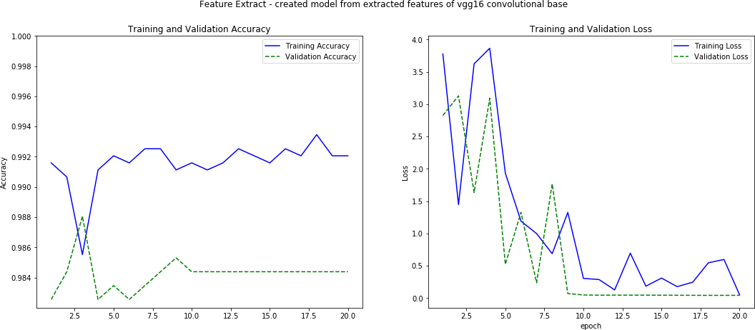

# Loading the convolutional base of model resnet50 for FE

[24]:

[105]:

base_dir = 'Data'

test_dir = 'keras-facenet/data/test' train_dir = os.path.join(base_dir, 'train')

validation_dir = os.path.join(base_dir, 'val')

datagen = ImageDataGenerator(rescale=1./255) batch_size = 20

**def** extract_features_resnet50(directory, sample_count): features = np.zeros(shape=(sample_count, 1, 1, 2048)) labels = np.zeros(shape=(sample_count))

*# Data Augmentation*

generator = datagen.flow_from_directory( directory,

conv_base_resnet50_FE =␣

*'→*VGGFace(input_shape=IMG_SHAPE,model='resnet50',weights='vggface',include_top=**False**)

[28]:

target_size=(IMG_SIZE, IMG_SIZE), batch_size=batch_size, class_mode='sparse')

i = 0

**for** inputs_batch, labels_batch **in** generator:

features_batch = conv_base_resnet50_FE.predict(inputs_batch) features[i * batch_size : (i + 1) * batch_size] = features_batch

labels[i * batch_size : (i + 1) * batch_size] = labels_batch i += 1

*# print(inputs_batch, labels_batch )*

## break

**if** i * batch_size >= sample_count:

*# Note that since generators yield data indefinitely in a loop, # we must `break` after every image has been seen once.*

## break

**return** features, labels

train_features_resnet50, train_labels_resnet50 =␣ *'→*extract_features_resnet50(train_dir, 2142) validation_features_resnet50, validation_labels_resnet50 =␣ *'→*extract_features_resnet50(validation_dir, 1089) test_features_resnet50, test_labels_resnet50 =␣ *'→*extract_features_resnet50(test_dir, 11)

Found 2142 images belonging to 11 classes. Found 1089 images belonging to 11 classes. Found 11 images belonging to 11 classes.

train_features_resnet50 = np.reshape(train_features_resnet50, (2142, 1 * 1 *␣

*'→*2048))

validation_features_resnet50 = np.reshape(validation_features_resnet50, (1089,␣

*'→*1 * 1 * 2048))

test_features_resnet50 = np.reshape(test_features_resnet50, (11, 1 * 1 * 2048))

[29]:

resnet50_FE = keras.models.Sequential() resnet50_FE.add(keras.layers.Dense(512, kernel_regularizer=regularizers. *'→*l2(lamb), activation='relu', input_dim=1 * 1 * 2048)) resnet50_FE.add(keras.layers.Dropout(0.5)) resnet50_FE.add(keras.layers.Dense(128, kernel_regularizer=regularizers. *'→*l2(lamb), activation='relu')) resnet50_FE.add(keras.layers.Dropout(0.5)) resnet50_FE.add(keras.layers.Dense(11, activation='softmax'))

resnet50_FE.compile(optimizer=keras.optimizers.Adam(lr=2e-2), loss='sparse_categorical_crossentropy',metrics=['accuracy'])

history_resnet50_FE = resnet50_FE.fit(train_features_resnet50,␣

*'→*train_labels_resnet50,

epochs=20, batch_size=20,

validation_data=(validation_features_resnet50,␣

*'→*validation_labels_resnet50))

|  |  |  |  |
| --- | --- | --- | --- |
| 2142/2142 [==============================] - 2s 768us/step | - loss: | 0.0646 | - |
| accuracy: 0.9921 - val_loss: 0.1199 - val_accuracy: 0.9862 |  |  |  |

[30]:

resnet50_FE.summary()

Model: "sequential_2"

Layer (type) Output Shape Param #

=================================================================

|  |  |  |  |  |
| --- | --- | --- | --- | --- |
| dense_165 | (Dense) | (None, | 512) | 1049088 |
| dropout_3 | (Dropout) | (None, | 512) | 0 |
| dense_166 | (Dense) | (None, | 128) | 65664 |
| dropout_4 | (Dropout) | (None, | 128) | 0 |
| dense_167 | (Dense) | (None, | 11) | 1419 |

=================================================================

Total params: 1,116,171

Trainable params: 1,116,171

Non-trainable params: 0

[31]:

plot_history(history_resnet50_FE, 'Feature Extract - created model from␣

*'→*extracted features of resnet50 ')

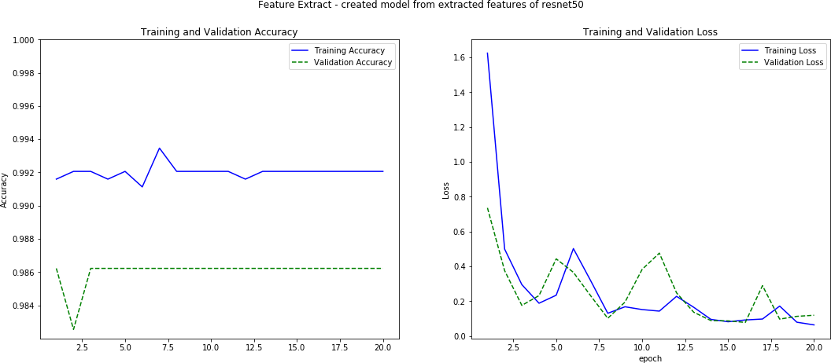

[33]:

resnet50_FE.save('resnet50_FE_30epochs.h5')

# Report:

* + The accuracy of training and test remains almost constant through different epochs. Also the loss of training and validation becomes almost equal in 20 epochs. No need for training with more epochs.
  + The validation accuracy remains less that training, but they are close.
  + 20 epochs seems to be a good choice, accuracy has been constant and loss values are decreasing across both training and validation.

# Transfer Learning (TL)

Build a model on top of the convolutional base of the VGG16 and ResNet50 Freeze the parameters of the convolutional base Train parameters in added dense and classification layers Use dropouts and regularizes for regularization to avoid overfitting

[37]:

# Data Augmentation

* Images are augmented based on horizontal flip, 45 rotation, and zooming for training. The validation images are not augmented.

pathFolder = './Data/' IMG_SIZE = 224

IMG_SHAPE = (IMG_SIZE, IMG_SIZE, 3)

*# image augmentation*

*# We are getting our train_generator, validation_generator and test_generator*␣

*'→ready :*

train_datagen=ImageDataGenerator(preprocessing_function=keras_vggface.utils.

*'→*preprocess_input,

horizontal_flip=**True**, rotation_range=45, zoom_range=[0.8,1.0])

test_datagen=ImageDataGenerator(preprocessing_function=keras_vggface.utils.

*'→*preprocess_input)

*# Training set*

pathTrain = pathFolder + 'train/'

listGroupsTrain = os.listdir(pathTrain) *# the directory path*

listGroupsTrain = [f **for** f **in** listGroupsTrain **if not** f.startswith('.')]

*# Validation set*

pathVal = pathFolder + 'val/'

listGroupsValid = os.listdir(pathVal) *# the directory path*

listGroupsValid = [f **for** f **in** listGroupsValid **if not** f.startswith('.')]

*# Tesing set*

test_dir = 'keras-facenet/data/test' listGroupsTest = os.listdir(test_dir)

listGroupsTest = [f **for** f **in** listGroupsTest **if not** f.startswith('.')]

*# Load the data into the ImageDataGenerator*

train_generator=train_datagen.flow_from_directory(pathFolder+'train',

target_size=(224,224), color_mode='rgb', batch_size=64, class_mode='categorical', shuffle=**True**, classes=listGroupsTrain)

validation_generator=test_datagen.flow_from_directory(pathFolder+'val',

target_size=(224,224), color_mode='rgb', batch_size=64, class_mode='categorical',

shuffle=**False**, classes=listGroupsValid)

test_generator = test_datagen.flow_from_directory(test_dir,

target_size=(224,224), color_mode='rgb',

batch_size=64, class_mode='categorical')

Found 2142 images belonging to 11 classes. Found 1089 images belonging to 11 classes. Found 11 images belonging to 11 classes.

# Steps Transfer learning :

- Get the convolutional base from the pretrained model

- Freeze the layers in the convolutional base

- Add dense layers and the classification layer to adjust added layer's weight by retrain model to my dataset's categories

- In one model, 1 hidden layer is added, in the next model, 2 hidden layers are added along with the classification layer.

[38]:

# Transfer Learning on ResNet50:

# Added 1 dense and a SoftMax layer and retrained the added layers:

* + Having conv base layers frozen.

conv_base_resnet50 = VGGFace(input_shape=IMG_SHAPE,model='resnet50',

weights='vggface',include_top=**False**) conv_base_resnet50.trainable = **False**

*# Regularize the dense layer by using L1*

kernel_weight = 0.02

bias_weight = 0.02

hidden_dim =512 resnet50_TL_1layer = Sequential([

conv_base_resnet50, keras.layers.Flatten(),

keras.layers.Dense(hidden_dim, activation='relu', name="FC_1", kernel_regularizer=regularizers.l1(kernel_weight), bias_regularizer=regularizers.l1(bias_weight)),

keras.layers.Dense(11, activation='softmax', name='FC_2', kernel_regularizer=regularizers.l1(kernel_weight),

bias_regularizer=regularizers.l1(bias_weight))])

*# compile*

resnet50_TL_1layer.compile(optimizer=keras.optimizers.RMSprop(lr=1e-5), loss='categorical_crossentropy' ,metrics=['accuracy'])

*# fit the model using similar hyperparameters as before* step_size_train=train_generator.n//train_generator.batch_size history_resnet50_TL_1layer= resnet50_TL_1layer.

*'→*fit_generator(generator=train_generator,

validation_data=validation_generator, steps_per_epoch=step_size_train, epochs=20)

resnet50_TL_1layer.save('resnet50_TL_1layer.h5') resnet50_TL_1layer.save_weights('resnet50_TL_1layer_weights.h5') plot_history(history_resnet50_TL_1layer, 'Transfer learning - Resnet50 -␣ *'→*re-trained added 1 hidden dense and output layers')

|  |  |  |  |  |
| --- | --- | --- | --- | --- |
| Epoch 20/20 |  |  |  |  |
| 33/33 [==============================] | - 210s 6s/step | - loss: | 398.1151 | - |
| accuracy: 0.7383 - val_loss: 395.7479 | - val_accuracy: | 0.7603 |  |  |
|  |  |  |  |  |

[111]:

plot_history(history_resnet50_TL_1layer, 'Transfer learning - Resnet50 -␣

*'→*re-trained added 1 hidden dense and output layers')

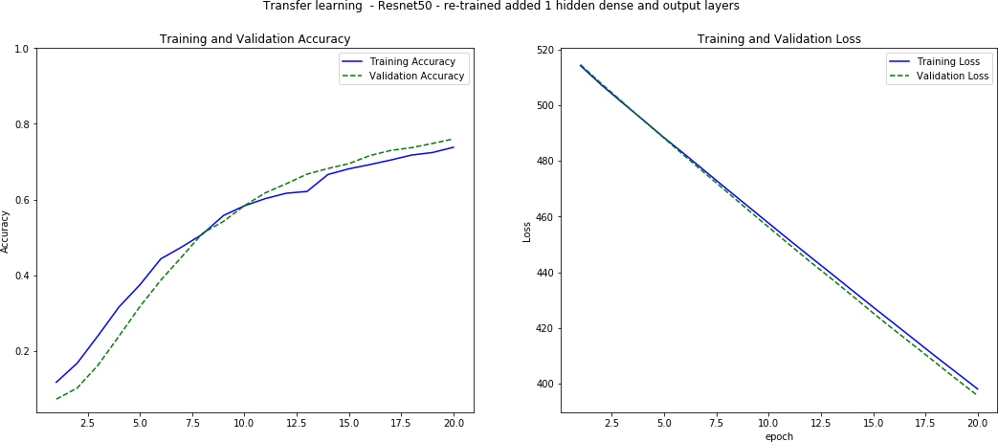

[41]:

# Added 2 dense and a SoftMax layer and retrained the added layers:

* + Having conv base layers frozen.

conv_base_resnet50 = VGGFace(input_shape=IMG_SHAPE,model='resnet50',

weights='vggface',include_top=**False**)

[44]:

keras.layers.Flatten(),

keras.layers.Dense(hidden_dim, activation='relu', name="FC_1"), keras.layers.Dense(hidden_dim, activation='relu', name="FC_2",

kernel_regularizer=regularizers.l1(kernel_weight), bias_regularizer=regularizers.l1(bias_weight)),

keras.layers.Dense(11, activation='softmax', name='FC_3', kernel_regularizer=regularizers.l1(kernel_weight),

*# base from resnet50*

conv_base_resnet50.trainable = **False** number_groupsTrain = len(listGroupsTrain) *# Regularize the dense layer by using L1* kernel_weight = 0.02

bias_weight = 0.02

hidden_dim =512

resnet50_TL = Sequential([ conv_base_resnet50,

bias_regularizer=regularizers.l1(bias_weight))])

resnet50_TL.summary()

Model: "sequential_4"

Layer (type) Output Shape Param #

=================================================================

|  |  |  |  |
| --- | --- | --- | --- |
| vggface_resnet50 (Model) | (None, | 1, 1, 2048) | 23561152 |
| flatten_71 (Flatten) | (None, | 2048) | 0 |
| FC_1 (Dense) | (None, | 512) | 1049088 |
| FC_2 (Dense) | (None, | 512) | 262656 |
| FC_3 (Dense) | (None, | 11) | 5643 |

=================================================================

Total params: 24,878,539

Trainable params: 1,317,387

Non-trainable params: 23,561,152

[45]:

resnet50_TL.compile(optimizer=keras.optimizers.RMSprop(lr=1e-5),

loss='categorical_crossentropy' ,metrics=['accuracy']) step_size_train=train_generator.n//train_generator.batch_size history_resnet50_TL = resnet50_TL.fit_generator(generator=train_generator,

validation_data=validation_generator, steps_per_epoch=step_size_train, epochs=20)

|  |  |  |  |  |
| --- | --- | --- | --- | --- |
| Epoch 20/20 |  |  |  |  |
| 33/33 [==============================] | - 213s 6s/step | - loss: | 174.5491 | - |
| accuracy: 0.9304 - val_loss: 173.6574 | - val_accuracy: | 0.9440 |  |  |

[112]

resnet50_TL.save('resnet50_TL.h5') resnet50_TL.save_weights('resnet50_TL_weights.h5')

[103]:

plot_history(history_resnet50_TL, 'Transfer learning - resnet50 - re-trained␣

*'→*added 2 hidden dense and output layers')

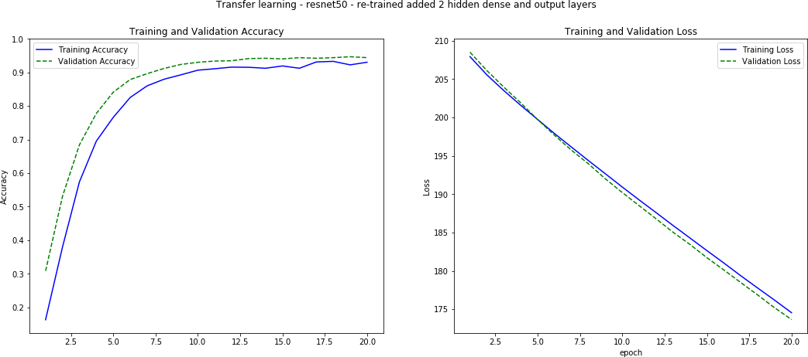

[ ]:

*# Create a function that goes through all images in test_dir and predicts them*␣

*'→using the specified model:*

[52]:

**def** FaceRecognition_testdata(model, listGroupsTest): i=0

**for** celeb **in** listGroupsTest:

**if not** celeb.startswith('.'):

test_img_path = os.path.join(test_dir, celeb)

**if not** test_img_path.startswith('.'):

**for** test_img **in** os.listdir(test_img_path):

**if not** test_img.startswith('.'):

test_identity = 'Not in database'

test_img_fullpath = os.path.join(test_img_path, test_img) face = extract_face(test_img_fullpath)

face = face.astype('float32') face = expand_dims(face, axis=0)

preprocessed_face = preprocess_input(face, version=2)

*#normalzed the color code*

*# preprocessed_face = face / 255*

prediction = model.predict(preprocessed_face)

**if** np.max(prediction) > 0.5:

name = np.argmax(prediction, axis=-1) test_identity = listGroupsTest[name[0]]

img = cv2.imread(os.path.join(test_img_path, test_img)) img_rgb = cv2.cvtColor(img, cv2.COLOR_BGR2RGB) plt.imshow(img_rgb)

plt.show()

print('test image is : ', test_identity)

[53]:

FaceRecognition_testdata(resnet50_TL, listGroupsTest)

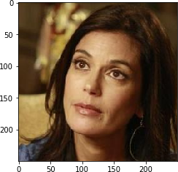

test image is : Teri_Hatcher

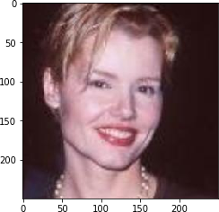

test image is : Geena_Davis

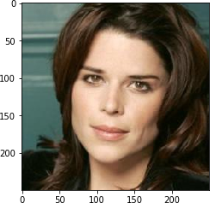

test image is : Neve_Campbell

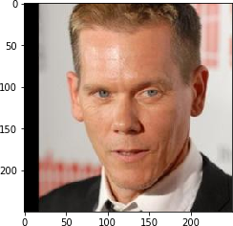

test image is : Kevin_Bacon

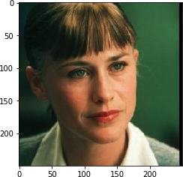

test image is : Patricia_Arquette

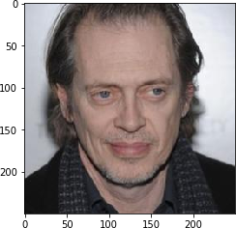

test image is : Steve_Buscemi

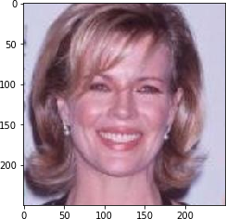

test image is : Kim_Basinger

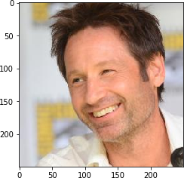

test image is : David_Duchovny

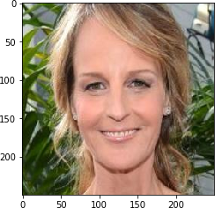

test image is : Helen_Hunt

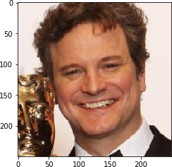

test image is : Colin_Firth

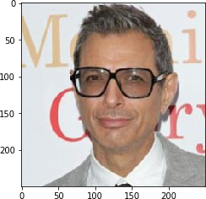

test image is : Jeff_Goldblum

[106]:

# Transfer Learning on VGG16:

# Add 1 hidden dense and output layer on the convolutional base and retrain added layers:

* + Having conv base layers frozen.

conv_base_vgg = VGGFace(input_shape=IMG_SHAPE,model='vgg16',

weights='vggface',include_top=**False**)

[60]:

conv_base_vgg.trainable = **False**

*# Regularize the dense layer by using L1*

kernel_weight = 0.02

bias_weight = 0.02

hidden_dim =512

vgg16_TL_1layer = Sequential([ conv_base_vgg, keras.layers.Flatten(),

keras.layers.Dense(hidden_dim, activation='relu', name="FC_1", kernel_regularizer=regularizers.l1(kernel_weight), bias_regularizer=regularizers.l1(bias_weight)),

keras.layers.Dense(11, activation='softmax', name='FC_2', kernel_regularizer=regularizers.l1(kernel_weight), bias_regularizer=regularizers.l1(bias_weight))])

vgg16_TL_1layer.compile(optimizer=keras.optimizers.RMSprop(lr=1e-5),

loss='categorical_crossentropy' ,metrics=['accuracy']) step_size_train=train_generator.n//train_generator.batch_size history_vgg16_TL_1layer= vgg16_TL_1layer.

*'→*fit_generator(generator=train_generator,

validation_data=validation_generator, steps_per_epoch=step_size_train, epochs=20)

vgg16_TL_1layer.save('vgg16_TL_1layer.h5') vgg16_TL_1layer.save_weights('vgg16_TL_1layer_weights.h5') plot_history(history_vgg16_TL_1layer, 'Transfer learning - vgg16 - re-trained␣ *'→*added 1 hidden dense and output layers')

|  |  |  |
| --- | --- | --- |
| Epoch 20/20 |  |  |
| 33/33 [==============================] - 321s 10s/step - loss: | 854.1662 | - |
| accuracy: 0.9328 - val_loss: 829.0189 - val_accuracy: 0.9458 |  |  |

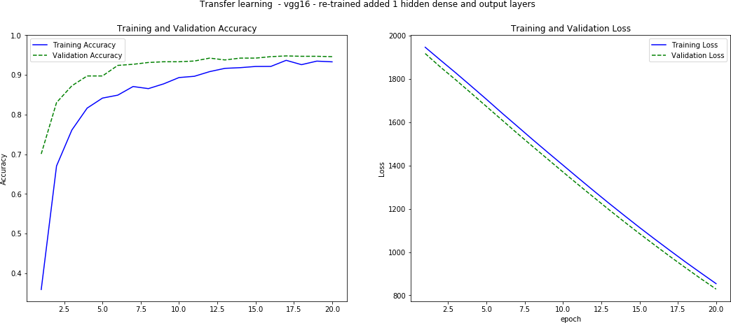

[62]:

# Add 2 hidden dense layers and output layer on the convolutional base and retrain added layers:

- having conv base layers frozen.

conv_base_vgg =␣

*'→*VGGFace(input_shape=IMG_SHAPE,model='vgg16',weights='vggface',include_top=**False**)

conv_base_vgg.trainable = **False**

*# Regularize the dense layer by using L1*

kernel_weight = 0.02

bias_weight = 0.02

hidden_dim =512 vgg16_TL = Sequential([

conv_base_vgg, keras.layers.Flatten(),

keras.layers.Dense(hidden_dim, activation='relu', name="FC_1", kernel_regularizer=regularizers.l1(kernel_weight), bias_regularizer=regularizers.l1(bias_weight)),

keras.layers.Dense(hidden_dim, activation='relu', name="FC_2",

kernel_regularizer=regularizers.l1(kernel_weight), bias_regularizer=regularizers.l1(bias_weight)),

keras.layers.Dense(11, activation='softmax', name='FC_3', kernel_regularizer=regularizers.l1(kernel_weight), bias_regularizer=regularizers.l1(bias_weight))])

vgg16_TL.summary()

Model: "sequential_7"

Layer (type) Output Shape Param #

=================================================================

|  |  |  |  |
| --- | --- | --- | --- |
| vggface_vgg16 (Model) | (None, | 7, 7, 512) | 14714688 |
| flatten_96 (Flatten) | (None, | 25088) | 0 |
| FC_1 (Dense) | (None, | 512) | 12845568 |
| FC_2 (Dense) | (None, | 512) | 262656 |
| FC_3 (Dense) | (None, | 11) | 5643 |

=================================================================

Total params: 27,828,555

Trainable params: 13,113,867

Non-trainable params: 14,714,688

[64]:

vgg16_TL.compile(optimizer=keras.optimizers.RMSprop(lr=1e-5),

loss='categorical_crossentropy' ,metrics=['accuracy'])

step_size_train=train_generator.n//train_generator.batch_size history_vgg16_TL= vgg16_TL.fit_generator(generator=train_generator,

validation_data=validation_generator,

steps_per_epoch=step_size_train, epochs=20)

[65]:

33/33 [==============================] - 321s 10s/step - loss: 961.2954 -

accuracy: 0.9219 - val_loss: 934.8681 - val_accuracy: 0.9403

vgg16_TL.save('vgg16_TL.h5') vgg16_TL.save_weights('vgg16_TL_weights.h5')

[66]:

*# vgg16_TL = load_model('vgg16_TL.h5')*

FaceRecognition_testdata(vgg16_TL, listGroupsTest)



test image is : Teri_Hatcher



test image is : Geena_Davis



test image is : Neve_Campbell



test image is : Kevin_Bacon



test image is : Colin_Firth



test image is : Steve_Buscemi



test image is : Kim_Basinger



test image is : David_Duchovny



test image is : Kim_Basinger



test image is : Colin_Firth



test image is : Jeff_Goldblum

[67]:

plot_history(history_vgg16_TL, 'Transfer learning - vgg16 - re-trained added 2␣

*'→*hidden dense and output layers ')

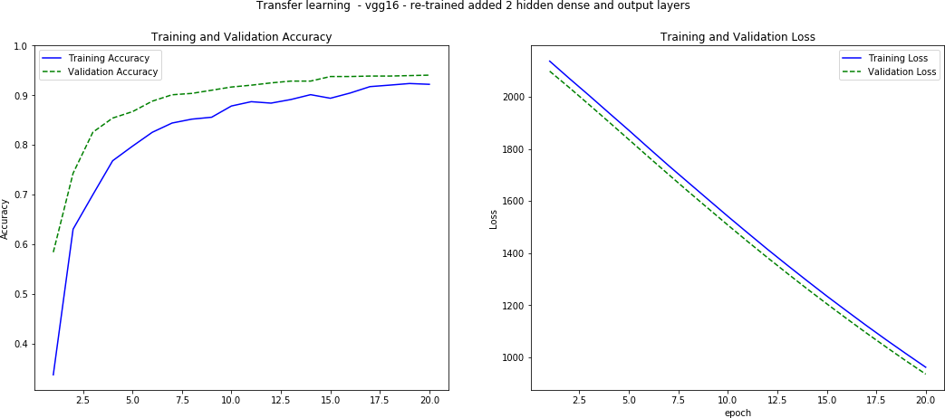

# Report:

* + Adding 2 hidden dense layers versus 1 hidden dense layer significantly improved the accuracy and the performance of the model created on Resnet50’s convolutional base (val acc increased from approximately 76% to approximately 94%).
  + However, in the case of models using VGG16’s convolutional base, the accuracy of the performance in both cases are ~ 94%
  + Validation and training accuracy and loss change together with a slight difference. The model is neither overfitting not underfitting
  + 20 epochs seem to be a good choice since loss has been decreasing and train and validation accuracy are very close. Neither overfitting nor underfitting.

# Fine Tuning:

* + Build a model on top of the convolutional base of the VGG16 and ResNet50
  + Unfreeze the parameters of all layers in the last convolutional block
  + The remaining layers in convolutional base are frozen
  + Train parameters in the last convolutional block, added dense and classification layers
  + Use regularizes for regularization to avoid overfitting

# Fine Tuning on ResNet50:

[72]:

conv_base_resnet_FT = VGGFace(input_shape=

IMG_SHAPE,␣

*'→*model='resnet50',weights='vggface', include_top=**False**)

*# The number of the layers in the base model*

NumOfLayers = len(conv_base_resnet_FT.layers) print("Number of layers in the base model: ", NumOfLayers)

Number of layers in the base model: 174

[74]:

conv_base_resnet_FT.trainable = **True**

**for** layer **in** conv_base_resnet_FT.layers[0:141]: layer.trainable = **False**

i+=1

[76]:

number_groupsTrain = len(listGroupsTrain)

*# Regularize the dense layer by using L1*

kernel_weight = 0.02

bias_weight = 0.02

hidden_dim =512

resnet50_FT = Sequential([ conv_base_resnet_FT, keras.layers.Flatten(),

keras.layers.Dense(hidden_dim, activation='relu', name="FC_1", kernel_regularizer=regularizers.l1(kernel_weight), bias_regularizer=regularizers.l1(bias_weight)),

keras.layers.Dense(11, activation='softmax', name='FC_2', kernel_regularizer=regularizers.l1(kernel_weight), bias_regularizer=regularizers.l1(bias_weight))

])

resnet50_FT.summary()

Model: "sequential_8"

Layer (type) Output Shape Param #

=================================================================

|  |  |  |  |
| --- | --- | --- | --- |
| vggface_resnet50 (Model) | (None, | 1, 1, 2048) | 23561152 |
| flatten_145 (Flatten) | (None, | 2048) | 0 |
| FC_1 (Dense) | (None, | 512) | 1049088 |
| FC_2 (Dense) | (None, | 11) | 5643 |

=================================================================

Total params: 24,615,883

Trainable params: 16,019,467

Non-trainable params: 8,596,416

[77]:

resnet50_FT.compile(optimizer=keras.optimizers.RMSprop(lr=1e-5),

loss='categorical_crossentropy' ,metrics=['accuracy']) step_size_train=train_generator.n//train_generator.batch_size history_resnet50_FT= resnet50_FT.fit_generator(generator=train_generator,

␣

*'→*validation_data=validation_generator,

steps_per_epoch=step_size_train, epochs=20)

[78]:

Epoch 20/20

33/33 [==============================] - 283s 9s/step - loss: 387.1705 -

accuracy: 0.9856 - val_loss: 384.0705 - val_accuracy: 0.9706

resnet50_FT.save('resnet50_FT.h5') resnet50_FT.save_weights('resnet50_FT_weights.h5')

[79]:

plot_history(history_resnet50_FT, 'Fine tuning - resnet50 - last convolutional␣

*'→*block (conv5) and added dense layers re-trained')

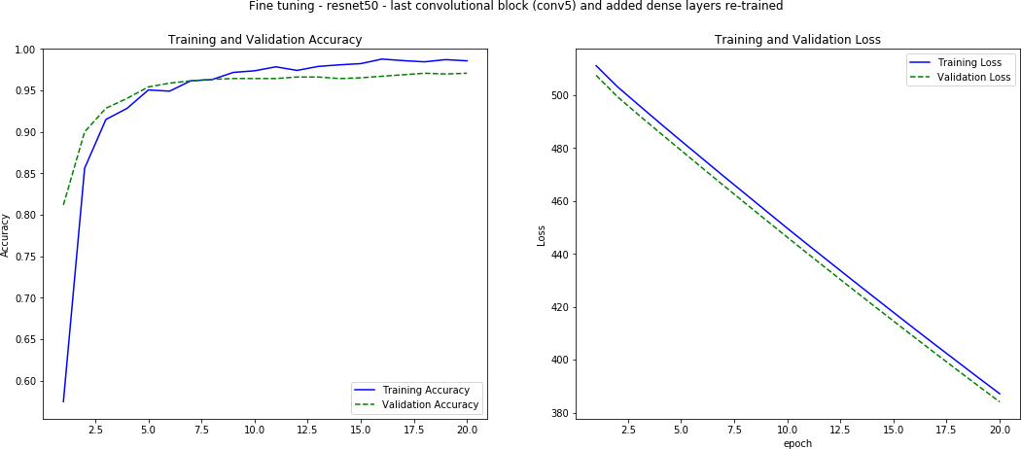

[80]:

FaceRecognition_testdata(resnet50_FT, listGroupsTest)



test image is : Teri_Hatcher



test image is : Geena_Davis



test image is : Neve_Campbell



test image is : Kevin_Bacon



test image is : Patricia_Arquette



test image is : Steve_Buscemi



test image is : Kim_Basinger



test image is : David_Duchovny



test image is : Helen_Hunt



test image is : Colin_Firth



test image is : Jeff_Goldblum

# Fine Tuning on VGG16:

[107]:

*# Fine-tune only the last convolution*

conv_base_vgg_FT = VGGFace(input_shape=

IMG_SHAPE,␣

*'→*model='vgg16',weights='vggface', include_top=**False**)

[88]:

*# The number of the layers in the base model*

NumOfLayers = len(conv_base_vgg_FT.layers)

print("Number of layers in the base model: ", NumOfLayers)

Number of layers in the base model: 19

[90]:

number_groupsTrain = len(listGroupsTrain)

*# Regularize the dense layer by using L1*

kernel_weight = 0.02

bias_weight = 0.02

hidden_dim =512 vgg16_FT = Sequential([

conv_base_vgg_FT, keras.layers.Flatten(),

keras.layers.Dense(hidden_dim, activation='relu', name="FC_1", kernel_regularizer=regularizers.l1(kernel_weight), bias_regularizer=regularizers.l1(bias_weight)),

keras.layers.Dense(11, activation='softmax', name='FC_2',*#)])*

kernel_regularizer=regularizers.l1(kernel_weight), bias_regularizer=regularizers.l1(bias_weight))])

vgg16_FT.summary()

Model: "sequential_10"

Layer (type) Output Shape Param #

=================================================================

|  |  |  |  |
| --- | --- | --- | --- |
| vggface_vgg16 (Model) | (None, | 7, 7, 512) | 14714688 |
| flatten_169 (Flatten) | (None, | 25088) | 0 |
| FC_1 (Dense) | (None, | 512) | 12845568 |
| FC_2 (Dense) | (None, | 11) | 5643 |

=================================================================

Total params: 27,565,899

Trainable params: 27,565,899

Non-trainable params: 0

[91]:

conv_base_vgg_FT.trainable = **True**

**for** layer **in** conv_base_vgg_FT.layers[0:15]: layer.trainable = **False**

i+=1

[92]:

**for** layer **in** conv_base_vgg_FT.layers: print(layer, layer.trainable)

[93]:

<keras.engine.input_layer.InputLayer object at 0x1ae413e7d0> False

<keras.layers.convolutional.Conv2D object at 0x1ae413e910> False

<keras.layers.convolutional.Conv2D object at 0x1ae7898290> False

<keras.layers.pooling.MaxPooling2D object at 0x1ae413ec10> False

<keras.layers.convolutional.Conv2D object at 0x1ae20cd0d0> False

<keras.layers.convolutional.Conv2D object at 0x1ae4145ad0> False

<keras.layers.pooling.MaxPooling2D object at 0x1ae212aed0> False

<keras.layers.convolutional.Conv2D object at 0x1ae20b8ed0> False

<keras.layers.convolutional.Conv2D object at 0x1ae414af90> False

<keras.layers.convolutional.Conv2D object at 0x1ae4150f10> False

<keras.layers.pooling.MaxPooling2D object at 0x1ae4156590> False

<keras.layers.convolutional.Conv2D object at 0x1ae415c590> False

<keras.layers.convolutional.Conv2D object at 0x1ae4161710> False

<keras.layers.convolutional.Conv2D object at 0x1ae4167e90> False

<keras.layers.pooling.MaxPooling2D object at 0x1ae41679d0> False

<keras.layers.convolutional.Conv2D object at 0x1ae416a9d0> True

<keras.layers.convolutional.Conv2D object at 0x1ae416fb50> True

<keras.layers.convolutional.Conv2D object at 0x1ae4175a10> True

<keras.layers.pooling.MaxPooling2D object at 0x1ae4175a50> True

vgg16_FT.compile(optimizer=keras.optimizers.RMSprop(lr=1e-5),

loss='categorical_crossentropy' ,metrics=['accuracy']) step_size_train=train_generator.n//train_generator.batch_size history_vgg16_FT= vgg16_FT.fit_generator(generator=train_generator,

␣

*'→*validation_data=validation_generator,

steps_per_epoch=step_size_train, epochs=20)

[94]:

Epoch 20/20

33/33 [==============================] - 360s 11s/step - loss: 759.6740 -

accuracy: 0.9557 - val_loss: 733.7641 - val_accuracy: 0.9568

vgg16_FT.save('vgg16_FT.h5') vgg16_FT.save_weights('vgg16_FT_weights.h5')

[96]:

plot_history(history_vgg16_FT, 'Fine tuning - vgg16 - last convolutional block␣

*'→*(conv5) and added Dense layers re-trained')

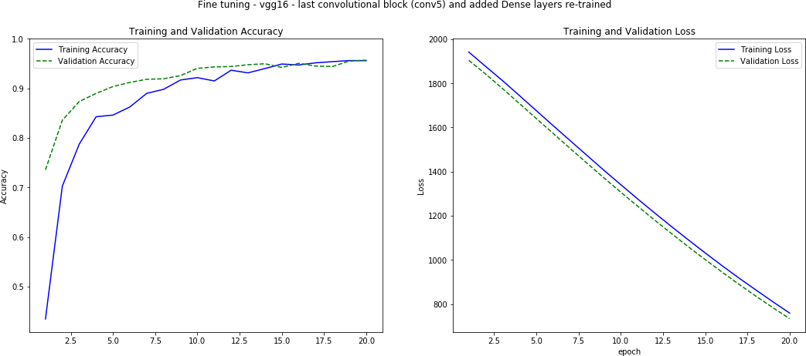

[97]:

FaceRecognition_testdata(vgg16_FT, listGroupsTest)



test image is : Teri_Hatcher



test image is : Geena_Davis



test image is : Neve_Campbell



test image is : Kevin_Bacon



test image is : Patricia_Arquette



test image is : Steve_Buscemi



test image is : Kim_Basinger



test image is : David_Duchovny



test image is : Helen_Hunt



test image is : Colin_Firth



test image is : Jeff_Goldblum

# Report:

* Finetuning improved the performance accuracies more than transfer learning in models using both architectures.
* Model using VGG16 convolutional base responded better than ReNet50 to the transfer learning regardless of the 1 or 2 layers added (with accuracy ~93%. val-acc ~94%). Model using ReNet50 convolutional base only compensated to the same accuracy when 2 hidden dense layers were added.
* Model using Resnet50 convolutional base responded to finetuning as both the training and validation accuracy increased to approximately 98%.

**Codes from notebook FaceRecognition_TinaRezvanian_CodePart2.ipynb:**

[1]:

# 3. What if we want to add another person to the existing database? or if the person in the image is not in our database? or we only have one Image per person in our database?

In the previous sections, we improved on the learning of existing pretrained models of VGG16 and ResNet50, using feature extraction, transfer learning, and finetuning with data augmentation and regularization. Both aforementioned models were trained on VGGFACE2 data. So far we have compared the performance of these two architectures in the repurposed models. If we show a picture of Bill Gate to any of the models in previous section, none will identify it as Not in database. They may classify him as anyone in database. The drawback of these models is that, if we are to add another person to our database, or we want to classify those not in our database as well, then we need to retrain models to include the additionally added people in database in the classes of the final output layer.

In this section, this project explores how deep learning models can be exploited such that we can add new members to our data base or identify those not in our database. Since we already compared two architectures trained on same dataset, I want to compare a model trained on a different dataset in this section. In addition, the purpose of this section is to answer how to deal with adding more people to database, also how to classify people if we only have one image from them, or what if the image is not from someone in our database. The difference of FaceNet with previously repurposed pretrained models is that FaceNet has learned a mapping from images to embeddings, rather than to classes in the final layer. Find detailed information [here](https://arxiv.org/abs/1503.03832). FaceNet model developed by Google and was trained on MS-Celeb-1M dataset ([here](https://www.microsoft.com/en-us/research/project/ms-celeb-1m-challenge-recognizing-one-%20million-celebrities-real-world/))) and expects input images to be color, to have their pixel values standardized across all three channels, and to have a square shape of 160×160 pixels. Also, it is possible that our database contains only one picture per person. So Face net model can overcome this issue as well. Download the pretrained model from [here](https://github.com/nyoki-mtl/keras-facenet).

**import os import pickle**

**import numpy as np import cv2**

**from numpy import** expand_dims

**from mtcnn.mtcnn import** MTCNN

**from keras.models import** load_model

**from PIL import** Image

**from numpy import** asarray

**from scipy.spatial import** distance

**import pickle import numpy as np**

**import matplotlib.pyplot as plt import cv2**

**from sklearn.preprocessing import** Normalizer

This model works with the following enviroment: python3.6.2/tensorflow: 1.3.0/keras: 2.1.2. in ‘facenet_path’ directory.

[2]:

facenet_path = 'keras-facenet/model/facenet_keras.h5' people_dir = 'keras-facenet/data/database'

test_dir = 'keras-facenet/data/test' required_size = (160,160)

[3]:

*# Create functions for shortening the codes*

1. : *# get embeddings of people’s face in my dataset*

**def** normalize(img):

mean, std = img.mean(), img.std()

**return** (img - mean) / std

**def** find_embedding(facenet_model, face, size): face = normalize(face)

face = cv2.resize(face, size)

encode = facenet_model.predict(np.expand_dims(face, axis=0))[0]

**return** encode

l2_normalizer = Normalizer('l2')

**def** extract_face(img_path, required_size=required_size):

*# load image from file*

img = cv2.imread(img_path)

img_rgb = cv2.cvtColor(img, cv2.COLOR_BGR2RGB)

*# create detector, using default weights*

detector = MTCNN()

*# detect faces in the image*

results = detector.detect_faces(img_rgb)

*# extract the bounding box associated to larger area*

bigger_face = max(results, key=**lambda** b: b['box'][2] * b['box'][3]) x1, y1, width, height = bigger_face['box']

x2, y2 = x1 + width, y1 + height

*# extract the face*

face = img_rgb[y1:y2, x1:x2] image = Image.fromarray(face)

image = image.resize(required_size) face_array = asarray(image)

x1, y1, width, height = box x1, y1 = abs(x1), abs(y1)

x2, y2 = x1 + width, y1 + height face = img_rgb[y1:y2, x1:x2] **return** face, (x1, y1), (x2, y2)

*extract the points in a image and its associated face*

*#*

**return** face_array

**def** get_points(img_rgb, box):

# Prepare our database from people image:

The output of the FaceNet model is a vector of size (128,). This vector represents the embedding of a face. I will create a database called ‘embedding_dict’, that will include the embeddings associated to image in the database.

1. Create a people directory including one image per subject as the database for FaceNet model

2. Capture embeddings of faces in database using FaceNet model

3. Capture embeddings of candidate faces for the 11 subjects

4. Compare the embeddings of candidate faces with database embeddings using a distance functi

1. : face_detector = MTCNN()

facenet_model = load_model(facenet_path)

embedding_dict = dict()

**for** celeb **in** os.listdir(people_dir):

**if not** celeb.startswith('.'):

person_dir = os.path.join(people_dir, celeb) embedding_list = []

**for** img_name **in** os.listdir(person_dir):

**if not** img_name.startswith('.'):

fullimagepath = os.path.join(person_dir, img_name) face = extract_face(fullimagepath)

face = normalize(face)

face = cv2.resize(face, required_size) face = expand_dims(face, axis=0)

embedding = facenet_model.predict(face)[0] embedding_list.append(embedding)

embedding = np.sum(embedding_list, axis=0)

embedding = l2_normalizer.transform(np.expand_dims(embedding, axis=0))[0] embedding_dict[celeb] = embedding

**for** key **in** embedding_dict.keys(): print(key)

[6]:

Teri_Hatcher Geena_Davis Neve_Campbell Kevin_Bacon Patricia_Arquette Steve_Buscemi Kim_Basinger David_Duchovny Helen_Hunt Colin_Firth Jeff_Goldblu

embedding.shape

[6]: (128,)

# Face Recognition:

- To identify if the candidate picture in the test_dir belongs to someone in our database, now it is sufficient to compare the embeddings that we saved in our 'embedding_dict' to the embedding of the candidate faces in the test_dir.

alpha_margin = 0.40

**for** celeb **in** os.listdir(test_dir):

**if not** celeb.startswith('.'):

test_img_path = os.path.join(test_dir, celeb)

**if not** test_img_path.startswith('.'):

**for** test_img **in** os.listdir(test_img_path):

**if not** test_img.startswith('.'):

test_face = extract_face(os.path.join(test_img_path, test_img)) test_embedding = find_embedding(facenet_model, test_face,␣

*'→*required_size)

test_embedding = l2_normalizer.transform(np.

*'→*expand_dims(test_embedding, axis=0))[0]

test_identity = 'Not in database'

**for** celeb_i **in** embedding_dict.keys(): embed_i = embedding_dict[celeb_i]

dissimilarity = distance.cosine(test_embedding, embed_i)

**if** dissimilarity < alpha_margin **and** dissimilarity <␣

*'→*temp_min_distance:

test_identity = celeb_i temp_min_distance = dissimilarity

img = cv2.imread(os.path.join(test_img_path, test_img)) img_rgb = cv2.cvtColor(img, cv2.COLOR_BGR2RGB) plt.imshow(img_rgb)

plt.show() plt.axis('off')

print('test image is : ', test_identity)



test image is : Teri_Hatcher



test image is : Geena_Davis



test image is : Neve_Campbell

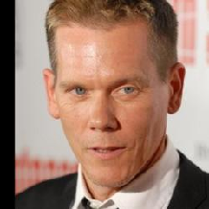

test image is : Kevin_Bacon



test image is : Patricia_Arquette

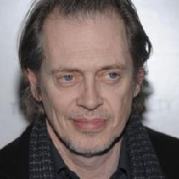

test image is : Steve_Buscemi



test image is : Kim_Basinger



test image is : David_Duchovny

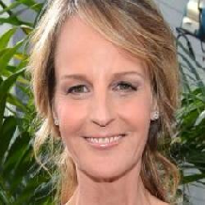

test image is : Helen_Hunt



test image is : Colin_Firth



test image is : Jeff_Goldblum

[13]:

alpha_margin = 0.40

**for** celeb **in** os.listdir(test_dir):

**if not** celeb.startswith('.'):

test_img_path = os.path.join(test_dir, celeb)

**if not** test_img_path.startswith('.'):

**for** test_img **in** os.listdir(test_img_path):

**if not** test_img.startswith('.'):

test_face = extract_face(os.path.join(test_img_path, test_img)) test_embedding = find_embedding(facenet_model, test_face,␣

*'→*required_size)

test_embedding = l2_normalizer.transform(np.

*'→*expand_dims(test_embedding, axis=0))[0]

temp_min_distance = float("inf") test_identity = 'Not in database'

**for** celeb_i **in** embedding_dict.keys(): embed_i = embedding_dict[celeb_i]

dissimilarity = distance.cosine(test_embedding, embed_i)

**if** dissimilarity < alpha_margin **and** dissimilarity <␣

*'→*temp_min_distance:

test_identity = celeb_i temp_min_distance = dissimilarity

img = cv2.imread(os.path.join(test_img_path, test_img)) img_rgb = cv2.cvtColor(img, cv2.COLOR_BGR2RGB) plt.imshow(img_rgb)

plt.show() plt.axis('off')

print('test image is : ', test_identity)



test image is : Teri_Hatcher



test image is : Geena_Davis



test image is : Neve_Campbell



test image is : Kevin_Bacon



test image is : Patricia_Arquette



test image is : Steve_Buscemi



test image is : Kim_Basinger



test image is : David_Duchovny



test image is : Helen_Hunt



test image is : Colin_Firth



test image is : Jeff_Goldblum

[8]:

# Create a generalized function for Face Recognition using model of interest:

This function identified the given faces selected in an image, given the model of interest. Then I will use this function to identify every face in an image using model of interest.

**def** classifyFace(model,size, face):

face = cv2.resize(face, required_size) face = np.expand_dims(face, axis=0) pred = model.predict(face) test_identity = 'Not in database'

**if** len(pred[0])!=128:

test_dir = 'keras-facenet/data/test' listGroupsTest = os.listdir(test_dir)

listGroupsTest = [f **for** f **in** listGroupsTest **if not** f.startswith('.')]

name = np.argmax(pred, axis=-1) test_identity = listGroupsTest[name[0]]

**else**:

**for** celeb_i **in** embedding_dict.keys(): embed_i = embedding_dict[celeb_i]

dissimilarity = distance.cosine(pred, embed_i)

**if** dissimilarity < alpha_margin:

test_identity = celeb_i

**return** test_identity

[9]:

# 4. What if there are multiple faces in the images?!

Image ‘test_3face.jpg’ includes 3 faces, 2 of which is in our database. in the following function I am performing a face recognition given a image with multiple faces in it. the prediction will be done through the model of interest, specified in the function arguments. since VGG16 and Resnet use (224,224) but FaceNet use (160,160), the required size should also be specified. this function also writes the resulting prediction on the image, and saves it with a string starting with your specified string, continued by the model name.

img_path = 'test_3face.jpg' required_size = (224, 224)

**def** face_recognition_multipleFaces(model, img_path, required_size, result_name): img = cv2.imread(img_path)

img_rgb = cv2.cvtColor(img, cv2.COLOR_BGR2RGB) detector = MTCNN()

result_faces = detector.detect_faces(img_rgb)

**for** box **in** result_faces:

face_i, xy1, xy2 = get_points(img_rgb, box['box']) face_i = normalize(face_i)

prediction = classifyFace(model, required_size, face_i) print(box, prediction)

cv2.rectangle(img, xy1, xy2 ,(0,0, 255),3)

cv2.putText(img,prediction, xy1,cv2.FONT_HERSHEY_PLAIN, 5, (0,0,255), 5) cv2.imwrite(str(result_name)+'.jpg',img)

**return** img

# Comparison of models on images with multiple face:

Here I am showing the predictions of models created using transfer learning and finetuning on the convolutional base of VGG16 and Resnet50

# Using Developed Models:

[26]:

img_path = 'test_3face.jpg' img = cv2.imread(img_path)

img_rgb = cv2.cvtColor(img, cv2.COLOR_BGR2RGB)

plt.imshow(img_rgb) plt.show()

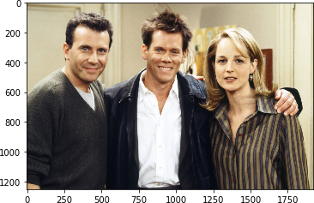

[16]:

models= ['vgg16_TL_1layer.h5','vgg16_TL.h5','vgg16_FT.h5','resnet50_TL_1layer.

*'→*h5',

'resnet50_TL2.h5','resnet50_FT.h5' ,'vgg16_FT.h5']

**for** m **in** range(len(models)): modelname = models[m]

model = load_model(modelname) required_size = (224, 224)

print("face recognition based on model: ", modelname)

FR_img = face_recognition_multipleFaces(model, img_path, required_size,␣

*'→*'result'+modelname+str(m))

img_rgb = cv2.cvtColor(FR_img, cv2.COLOR_BGR2RGB) plt.imshow(img_rgb)

plt.show()

face recognition based on model: vgg16_TL_1layer.h5

{'box': [817, 200, 221, 311], 'confidence': 0.9999356269836426, 'keypoints':

{'left_eye': (891, 319), 'right_eye': (992, 333), 'nose': (940, 389),

'mouth_left': (876, 425), 'mouth_right': (979, 438)}} Kevin_Bacon

{'box': [296, 180, 255, 348], 'confidence': 0.9996943473815918, 'keypoints':

{'left_eye': (394, 313), 'right_eye': (504, 321), 'nose': (460, 400),

'mouth_left': (379, 432), 'mouth_right': (491, 439)}} Colin_Firth

{'box': [1263, 265, 233, 310], 'confidence': 0.9994908571243286, 'keypoints':

{'left_eye': (1314, 392), 'right_eye': (1425, 391), 'nose': (1357, 451),

'mouth_left': (1320, 511), 'mouth_right': (1411, 511)}} Helen_Hunt

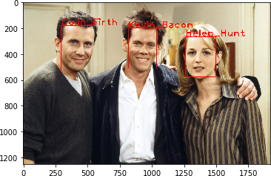

face recognition based on model: vgg16_TL.h5

{'box': [817, 200, 221, 311], 'confidence': 0.9999356269836426, 'keypoints':

{'left_eye': (891, 319), 'right_eye': (992, 333), 'nose': (940, 389),

'mouth_left': (876, 425), 'mouth_right': (979, 438)}} Kevin_Bacon

{'box': [296, 180, 255, 348], 'confidence': 0.9996943473815918, 'keypoints':

{'left_eye': (394, 313), 'right_eye': (504, 321), 'nose': (460, 400),

'mouth_left': (379, 432), 'mouth_right': (491, 439)}} Kevin_Bacon

{'box': [1263, 265, 233, 310], 'confidence': 0.9994908571243286, 'keypoints':

{'left_eye': (1314, 392), 'right_eye': (1425, 391), 'nose': (1357, 451),

'mouth_left': (1320, 511), 'mouth_right': (1411, 511)}} Helen_Hunt

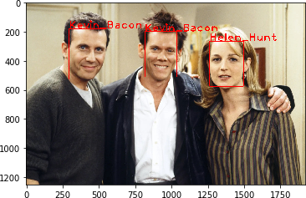

face recognition based on model: vgg16_FT.h5

{'box': [817, 200, 221, 311], 'confidence': 0.9999356269836426, 'keypoints':

{'left_eye': (891, 319), 'right_eye': (992, 333), 'nose': (940, 389),

'mouth_left': (876, 425), 'mouth_right': (979, 438)}} Kevin_Bacon

{'box': [296, 180, 255, 348], 'confidence': 0.9996943473815918, 'keypoints':

{'left_eye': (394, 313), 'right_eye': (504, 321), 'nose': (460, 400),

'mouth_left': (379, 432), 'mouth_right': (491, 439)}} Jeff_Goldblum

{'box': [1263, 265, 233, 310], 'confidence': 0.9994908571243286, 'keypoints':

{'left_eye': (1314, 392), 'right_eye': (1425, 391), 'nose': (1357, 451),

'mouth_left': (1320, 511), 'mouth_right': (1411, 511)}} Teri_Hatcher

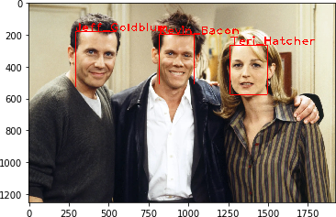

face recognition based on model: resnet50_TL_1layer.h5

{'box': [817, 200, 221, 311], 'confidence': 0.9999356269836426, 'keypoints':

{'left_eye': (891, 319), 'right_eye': (992, 333), 'nose': (940, 389),

'mouth_left': (876, 425), 'mouth_right': (979, 438)}} Steve_Buscemi

{'box': [296, 180, 255, 348], 'confidence': 0.9996943473815918, 'keypoints':

{'left_eye': (394, 313), 'right_eye': (504, 321), 'nose': (460, 400),

'mouth_left': (379, 432), 'mouth_right': (491, 439)}} Steve_Buscemi

{'box': [1263, 265, 233, 310], 'confidence': 0.9994908571243286, 'keypoints':

{'left_eye': (1314, 392), 'right_eye': (1425, 391), 'nose': (1357, 451),

'mouth_left': (1320, 511), 'mouth_right': (1411, 511)}} Steve_Buscemi

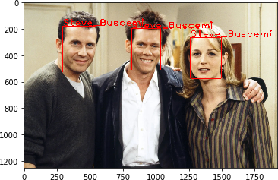

face recognition based on model: resnet50_TL.h5

{'box': [817, 200, 221, 311], 'confidence': 0.9999356269836426, 'keypoints':

{'left_eye': (891, 319), 'right_eye': (992, 333), 'nose': (940, 389),

'mouth_left': (876, 425), 'mouth_right': (979, 438)}} Helen_Hunt

{'box': [296, 180, 255, 348], 'confidence': 0.9996943473815918, 'keypoints':

{'left_eye': (394, 313), 'right_eye': (504, 321), 'nose': (460, 400),

'mouth_left': (379, 432), 'mouth_right': (491, 439)}} Helen_Hunt

{'box': [1263, 265, 233, 310], 'confidence': 0.9994908571243286, 'keypoints':

{'left_eye': (1314, 392), 'right_eye': (1425, 391), 'nose': (1357, 451),

'mouth_left': (1320, 511), 'mouth_right': (1411, 511)}} Helen_Hunt

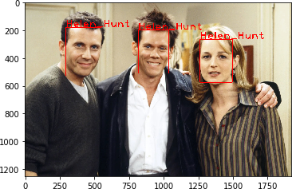

face recognition based on model: resnet50_FT.h5

{'box': [817, 200, 221, 311], 'confidence': 0.9999356269836426, 'keypoints':

{'left_eye': (891, 319), 'right_eye': (992, 333), 'nose': (940, 389),

'mouth_left': (876, 425), 'mouth_right': (979, 438)}} Colin_Firth

{'box': [296, 180, 255, 348], 'confidence': 0.9996943473815918, 'keypoints':

{'left_eye': (394, 313), 'right_eye': (504, 321), 'nose': (460, 400),

'mouth_left': (379, 432), 'mouth_right': (491, 439)}} Neve_Campbell

{'box': [1263, 265, 233, 310], 'confidence': 0.9994908571243286, 'keypoints':

{'left_eye': (1314, 392), 'right_eye': (1425, 391), 'nose': (1357, 451),

'mouth_left': (1320, 511), 'mouth_right': (1411, 511)}} Neve_Campbell

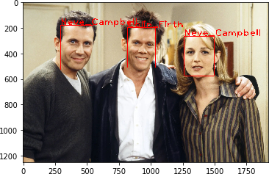

face recognition based on model: vgg16_FT.h5

{'box': [817, 200, 221, 311], 'confidence': 0.9999356269836426, 'keypoints':

{'left_eye': (891, 319), 'right_eye': (992, 333), 'nose': (940, 389),

'mouth_left': (876, 425), 'mouth_right': (979, 438)}} Kevin_Bacon

{'box': [296, 180, 255, 348], 'confidence': 0.9996943473815918, 'keypoints':

{'left_eye': (394, 313), 'right_eye': (504, 321), 'nose': (460, 400),

'mouth_left': (379, 432), 'mouth_right': (491, 439)}} Jeff_Goldblum

{'box': [1263, 265, 233, 310], 'confidence': 0.9994908571243286, 'keypoints':

{'left_eye': (1314, 392), 'right_eye': (1425, 391), 'nose': (1357, 451),

'mouth_left': (1320, 511), 'mouth_right': (1411, 511)}} Teri_Hatcher



[ ]:

*# Using less clear images*

[30]:

img_path = '3.jpg'

multi_face_imgs_path = 'multi_face_imgs'

*# multi_face_imgs_dir = os.listdir(multi_face_imgs_path)*

fullimagepath = os.path.join(multi_face_imgs_path, img_path)

models= ['vgg16_TL_1layer.h5','vgg16_TL.h5','resnet50_TL_1layer.

*'→*h5','resnet50_FT.h5' ]

**for** m **in** range(len(models)): modelname = models[m]

model = load_model(modelname) required_size = (224, 224)

print("face recognition based on model: ", modelname)

FR_img = face_recognition_multipleFaces(model, fullimagepath,␣

*'→*required_size, 'result'+modelname+str(m))

img_rgb = cv2.cvtColor(FR_img, cv2.COLOR_BGR2RGB) plt.imshow(img_rgb)

plt.show()

face recognition based on model: vgg16_TL_1layer.h5

{'box': [1603, 188, 149, 204], 'confidence': 0.9999979734420776, 'keypoints':

{'left_eye': (1669, 266), 'right_eye': (1734, 273), 'nose': (1712, 312),

'mouth_left': (1663, 336), 'mouth_right': (1724, 343)}} Steve_Buscemi

{'box': [358, 194, 169, 226], 'confidence': 0.9999855756759644, 'keypoints':

{'left_eye': (412, 279), 'right_eye': (489, 288), 'nose': (446, 325),

'mouth_left': (406, 357), 'mouth_right': (477, 368)}} Colin_Firth

{'box': [750, 327, 158, 220], 'confidence': 0.9998832941055298, 'keypoints':

{'left_eye': (800, 417), 'right_eye': (870, 415), 'nose': (844, 456),

'mouth_left': (805, 488), 'mouth_right': (872, 485)}} Colin_Firth

{'box': [1472, 431, 149, 200], 'confidence': 0.9992914199829102, 'keypoints':

{'left_eye': (1527, 509), 'right_eye': (1595, 507), 'nose': (1570, 548),

'mouth_left': (1526, 577), 'mouth_right': (1590, 576)}} Helen_Hunt

{'box': [1102, 317, 141, 189], 'confidence': 0.9990731477737427, 'keypoints':

{'left_eye': (1145, 395), 'right_eye': (1210, 391), 'nose': (1187, 430),

'mouth_left': (1147, 456), 'mouth_right': (1213, 451)}} Helen_Hunt

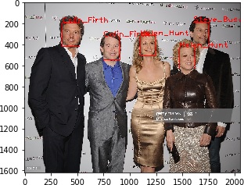

face recognition based on model: vgg16_TL.h5

{'box': [1603, 188, 149, 204], 'confidence': 0.9999979734420776, 'keypoints':

{'left_eye': (1669, 266), 'right_eye': (1734, 273), 'nose': (1712, 312),

'mouth_left': (1663, 336), 'mouth_right': (1724, 343)}} Steve_Buscemi

{'box': [358, 194, 169, 226], 'confidence': 0.9999855756759644, 'keypoints':

{'left_eye': (412, 279), 'right_eye': (489, 288), 'nose': (446, 325),

'mouth_left': (406, 357), 'mouth_right': (477, 368)}} Colin_Firth

{'box': [750, 327, 158, 220], 'confidence': 0.9998832941055298, 'keypoints':

{'left_eye': (800, 417), 'right_eye': (870, 415), 'nose': (844, 456),

'mouth_left': (805, 488), 'mouth_right': (872, 485)}} Steve_Buscemi

{'box': [1472, 431, 149, 200], 'confidence': 0.9992914199829102, 'keypoints':

{'left_eye': (1527, 509), 'right_eye': (1595, 507), 'nose': (1570, 548),

'mouth_left': (1526, 577), 'mouth_right': (1590, 576)}} Colin_Firth

{'box': [1102, 317, 141, 189], 'confidence': 0.9990731477737427, 'keypoints':

{'left_eye': (1145, 395), 'right_eye': (1210, 391), 'nose': (1187, 430),

'mouth_left': (1147, 456), 'mouth_right': (1213, 451)}} Helen_Hunt

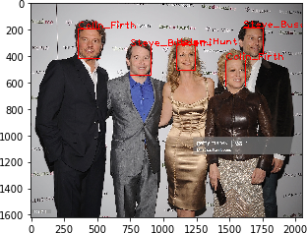

face recognition based on model: resnet50_TL_1layer.h5

{'box': [1603, 188, 149, 204], 'confidence': 0.9999979734420776, 'keypoints':

{'left_eye': (1669, 266), 'right_eye': (1734, 273), 'nose': (1712, 312),

'mouth_left': (1663, 336), 'mouth_right': (1724, 343)}} Steve_Buscemi

{'box': [358, 194, 169, 226], 'confidence': 0.9999855756759644, 'keypoints':

{'left_eye': (412, 279), 'right_eye': (489, 288), 'nose': (446, 325),

'mouth_left': (406, 357), 'mouth_right': (477, 368)}} Steve_Buscemi

{'box': [750, 327, 158, 220], 'confidence': 0.9998832941055298, 'keypoints':

{'left_eye': (800, 417), 'right_eye': (870, 415), 'nose': (844, 456),

'mouth_left': (805, 488), 'mouth_right': (872, 485)}} Steve_Buscemi

{'box': [1472, 431, 149, 200], 'confidence': 0.9992914199829102, 'keypoints':

{'left_eye': (1527, 509), 'right_eye': (1595, 507), 'nose': (1570, 548),

'mouth_left': (1526, 577), 'mouth_right': (1590, 576)}} Steve_Buscemi

{'box': [1102, 317, 141, 189], 'confidence': 0.9990731477737427, 'keypoints':

{'left_eye': (1145, 395), 'right_eye': (1210, 391), 'nose': (1187, 430),

'mouth_left': (1147, 456), 'mouth_right': (1213, 451)}} Steve_Buscemi

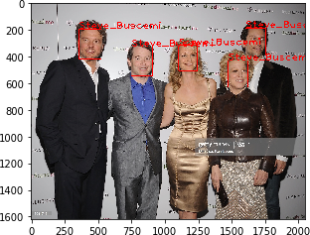

face recognition based on model: resnet50_FT.

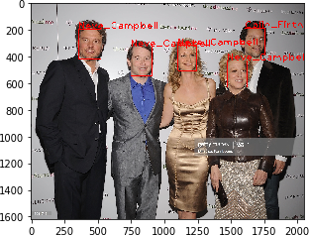

# Using FaceNet Model:

[11]:

multi_face_imgs_path = 'multi_face_imgs' multi_face_imgs_dir = os.listdir(multi_face_imgs_path) **for** multi **in** multi_face_imgs_dir:

**if not** multi.startswith('.'):

fullimagepath = os.path.join(multi_face_imgs_path, multi)

required_size = (160, 160)

print("face recognition based on model: FaceNet model")

FR_img = face_recognition_multipleFaces(facenet_model, fullimagepath,␣

*'→*required_size, 'result'+modelname+str(m))

img_rgb = cv2.cvtColor(FR_img, cv2.COLOR_BGR2RGB) plt.imshow(img_rgb)

plt.show()

face recognition based on model: FaceNet model

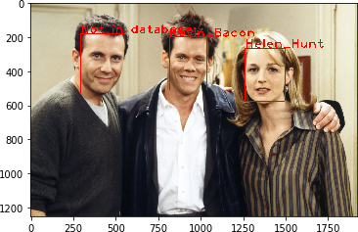

face recognition based on model: FaceNet model

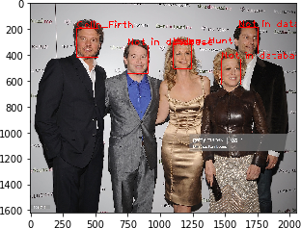

face recognition based on model: FaceNet model

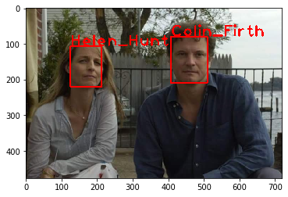

# Summary and Explanation of Reports:

1. Repurposing existing models, using a moderate size dataset, to match an extracted face to a known individual can significantly improve the prediction accuracy of pretrained models.
2. The performance of repurposed models strongly depends on the underlying network architecture and not necessarily the depth or number of layers. VGG16 yields higher validation accuracy with less layers retrained. VGG16 and Resnet50 models are both pretrained on the same VGGFace2 dataset. However, when more of the layers are retrained, model using ResNet50 improved more.
3. Fine tuning improved the validation accuracies more than transfer learning in models created VGG16 and ResNet50’s convolutional base.
4. Models using VGG16’s convolutional base responded better than ReNet50 to the transfer learning regardless of the 1 or 2 layers added. Models using ReNet50’s convolutional base only compensated to the same accuracy when 2 hidden dense layers were added.
5. Model using Resnet50’s convolutional base responded better than VGG16 to finetuning. (model using VGG16 convolutional base improved from ~93% in TL to ~ 95% in FT, while using Resnet50 improved from ~93% in TL to ~97% in FT)
6. Models in Transfer learning and finetuning provided a better fit than models created using extracted features. In transfer learning and fine-tuning sections, training and validation accuracy improved together and remain very close. Models are neither overfitting nor underfitting. On the other hand, in the models created using extracted features, the validation accuracy remains less training accuracy.
7. The performance of repurposed models strongly depends on the number of images in the underlying datasets of pretrained models, as FaceNet with 1 million identities strongly over performs VGG16 and ResNet50 with 9,131 identities.
8. The initial dataset used to train them and not necessarily the depth or number of layers.